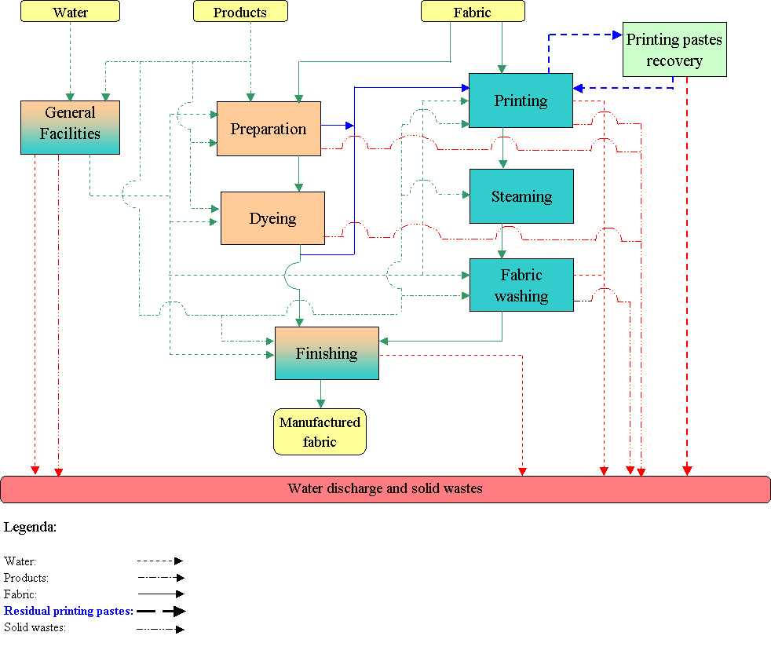
An.1: Material flow chart (example)

An.2: Energetic flow chart (example)

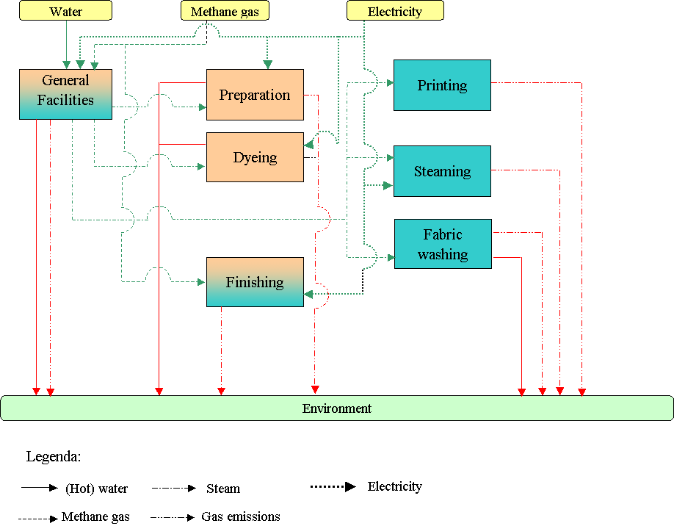
An. 3: Water flow chart (example)
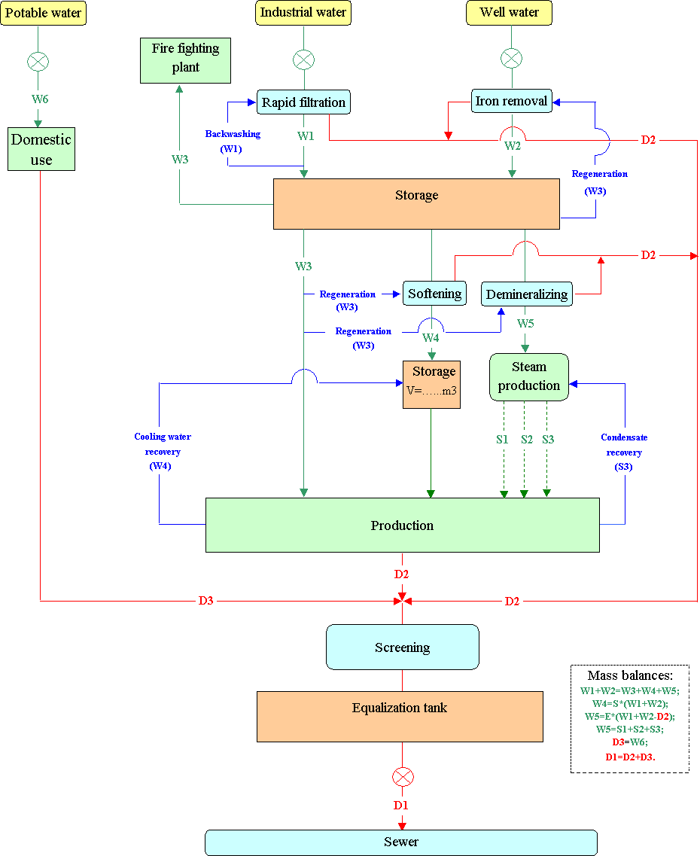

An.5a: Batch process scheme.

Department
Fabric (Yarn, …)
Process
Equipment
Item
Run time (h,m)
Number of run/yr
Processed fabric (kg/yr)
Processed fabric per run (kg)

Water type.  chemical 1 (code (*)): (g/l or % on weight);  chemical 2 (code (*)): (g/l or % on weight);  …….  auxiliary 1 (code (*): (g/l or % on weight);  auxiliary 2 (code (*)) (g/l or % on weight);  …….  Steam type. | Step 1  T1=…..; t1=…..  T2=…..; t2=…..  ............  Direct (indirect) heating
 | Discharge |  | Discharge type:  T [°C]=;  pH [-]=;  Conductivity [mS/cm]=;  COD [mg/l]=.  TSS [mg/l]=
Water type.  chemical 1 (code (*)): (g/l or % on weight);  chemical 2 (code (*)): (g/l or % on weight);  …….  auxiliary 1 (code (*): (g/l or % on weight);  auxiliary 2 (code (*)) (g/l or % on weight);  …….  Steam type. | Step 2  T1=…..; t1=…..  T2=…..; t2=…..  ............  Direct (indirect) heating
 | Discharge |  | Discharge type :  T [°C]=;  pH [-]=;  Conductivity [mS/cm]=;  COD [mg/l]=.  TSS [mg/l]=

Notes:

(*) :refer to An. 9.

An.5a: Batch process scheme (example).

Department | Dyeing
Fabric (Yarn, …) | Mix-PES
Process | Light colour dyeing (Disperse dyestuffs)
Equipment | Jigger
Item | J1
Run time (h,m) | 6,15
Number of run/yr | 21
Processed fabric (kg/yr) | 55000
Processed fabric per run (kg) | 2620

Water type W1: 2000 l  Direct dyestuffs<0,05%  Sodium sulphide (12): 40 g/l  Dispersant agent (54): 1 g/l  Steam type.S1 | Bath  T=60°C;  t=30 min  Indirect heating
 | Discharge |  | Discharge type D1: 2000 l  T [°C]=65;  pH [-]=9;  Conductivity [mS/cm]=3000;  COD [mg/l]=1500  TSS [mg/l]= 200
Water type W2: 2000 l | Rinsing
 | Discharge |  | Discharge type D1: 2000 l  T [°C]=30;  pH [-]=8;  Conductivity [mS/cm]=800;  COD [mg/l]=450.  TSS [mg/l]= 50

Notes:

For LCA product: see An.D

An.5.b: Continuous process scheme

Department
Fabric (Yarn, …)
Process
Equipment
Item
Operating
Number of cycles/yr
Cycle time (h,m)
Processed fabric (yarn) (kg/yr)
Processed fabric (yarn) per hour (kg/h)

Water type.  chemical 1 (code (*)): (g/l or % on weight);  chemical 2 (code (*)): (g/l or % on weight);  …….  auxiliary 1 (code (*)): (g/l or % on weight);  auxiliary 2 (code (*)):(g/l or % on weight);  …….  Steam type.  Water type.  ……..  Water type.  …… | Step 1  Step2  Step3 | Discharge type.  T [°C]=;  pH [-]=;  Conductivity [mS/cm]=;  COD [mg/l]=.  TSS [mg/l]=  Discharge type.  T [°C]=;  pH [-]=;  Conductivity [mS/cm]=;  COD [mg/l]=.  TSS [mg/l]=  Discharge type.  T [°C]=;  pH [-]=;  Conductivity [mS/cm]=;  COD [mg/l]=.  TSS [mg/l]=

Notes:

(*):refer to An.9

An.5.b: Continuous process scheme (example)

Department | Finishing
Fabric (Yarn, …) | Mix-PES
Process | Water Finishing
Equipment | Rameuse
Item | R1
Operating | continuous
Number of cycles/year | 400
Cycle time (h,m) | 35,5
Processed fabric (yarn) (kg/yr) | 200000
Processed fabric (yarn) per hour (kg/h) | 572

Water type W1: 80 l/h. | Doping  Wringing  Thermosetting  (T= 110 °C) | Discharge type 1: 40 l/h  T [°C]=28;  pH [-]=9;  Conductivity [mS/cm]=300;  COD [mg/l]=250.  TSS [mg/l]= 30

Notes:

For LCA product: see An.D

An.5c: General Facilities process scheme.

Dept
Process
Operating (continuous)
Equipment
Item
Number of run/yr
Run time (h,m)
Number of cycles/yr
Cycle time (h,m)
…………………
…………………

Water type.  chemical 1 (code (*)):(g/l or % on weight);  chemical 2 (code (*)):(g/l or % on weight);  …….  auxiliary 1 (code (*)): (g/l or % on weight);  auxiliary 2 (code (*)) ; (g/l or % on weight);  …….  Steam type. | Step 1 |  | Output  Discharge type  T [°C]=;  pH [-]=;  Conductivity [mS/cm]=;  COD [mg/l]=.  TSS [mg/l]=
Water type. | Step 2 |  | Discharge type  T [°C]=;  pH [-]=;  Conductivity [mS/cm]=;  COD [mg/l]=.  TSS [mg/l]=
Water type. | Step 3 |  | Discharge type  T [°C]=;  pH [-]=;  Conductivity [mS/cm]=;  COD [mg/l]=.  TSS [mg/l]=

Notes:

(*):refer to An.9
An.5c: General facilities process scheme (example).

Dept | General Facilities
Process | Steam production
Operating | continuous
Equipment | Boiler
Item | B1
Run time (h,m) | -
Number of run/yr | -
Number of cycles/yr | -
Cycle time (h) | -
Operating hours | 4000

 | Boiler
Water type W2: 2000 l/h  0,5 l solution containing:  Water type W2=20 l;  Deoxygenating agent (29) =9 l. | Evaporator  -  Heat exchanger |  | Direct use steam  1500 l/h  Discharge type D1: 500 l/h (each 1 h for 100 sec)  T [°C]=40;  pH [-]=7;  Conductivity [mS/cm]=800;  COD [mg/l]=4500.  TSS [mg/l]=0,5

Notes:

