Section 5: Executive Publishable Summary, Related To The Overall Project Duration
Contract n° | EVK1-CT-2000-00063 | Project Duration: | 1/3/2001 – 28/2/2004
Title | EVALUATION OF THE EFFECT OF THE IPPC APPLICATION ON THE SUSTAINABLE WASTE MANAGEMENT IN TEXTILE INDUSTRIES (TOWEF0)
Objectives:
- Survey on Good Environmental Practices (GEP) in the textile finishing industry and selection of 10 representative companies based on the survey results.
- Process data collection for technical/economical evaluation in the companies selected.
- Design of optimised water re-use schemes by Water Pinch application.
- Characterisation of textile wastewater in terms of treatability and re-usability. Calorimetric and respirometric tests. Development of innovative on-line wastewater characterisation technique.
- Membrane treatment of process effluents. Operational data and economical evaluations. Anaerobic pre-treatment of dyeing wastewaters. Evaluation of the aerobic treatability of final effluents.
- Reuse tests using membrane treated water in lab-scale textile processes.
- Analytical methods for organic micro-pollutants and ecotoxicity evaluations. Physical-chemical and eco-toxicological monitoring campaigns of textile discharges and receiving water bodies.
- Life Cycle Assessment (LCA) application in the selected textile industries. Database supporting the LCA software. Evaluation and comparison of water reuse scenarios.
- Development of the LCA software tool.
- Regulatory policy for water management in textile industry.
- Integration of all the results obtained in a Multicriteria Methodology.

Scientific achievements:
- A questionnaire was conceived to allow the collection of information on emission and consumption levels and GEP application in the European textile finishing industry. Analysis and conclusions were extracted from the questionnaires and a selection of ten representative companies was made. Data of the GEP survey were included in the textile BREF.
- A manual for process identification and data collection in textile industries was conceived and the data collection was completed. Each relevant process was evaluated and defined in terms of manufactured fibres, equipment, process features and the main steps were identified. All reagents dosage and concentration were collected as well as water and steam consumption. Discharged water was characterised for all departments and main processes and its contribution to the final wastewater in terms of quantity and pollution load was assessed by mass balances.
- A methodology for the application of Water Pinch technology in the textile industry was set up. Water re-use schemes, implementing regeneration technologies, were designed and water saving potential were assessed. The contamination of the final effluent and the cost for the implementation of innovative reuse scenarios were calculated as well.
- A comprehensive literature review textile industry wastewater characterisation was carried out. An automatic respirometer was set up for the characterisation experiments, and a methodology was devised to test the textile wastewater. A series of respirometry experiments was done with samples of mixed textile wastewater and process streams. Calorimetric measurements were carried out in a calorimeter whose sensibility was gradually improved, comparing them with established respirometric techniques and obtaining the same information in terms of biodegradability and toxicity of the wastewaters. A number of samples were analysed using the infrared characterisation technique. An on-line characterisation technique was developed consisting of respirometric analysis of the short-term BOD concentration of a wastewater, combined with its COD value determined using on-line infrared spectrometry. Combination of the two values into a BOD/COD ratio gives a measure for the biological treatability of effluents. Automation of the respirogram analysis was done using a neural network.
- Membrane treatment was tested on significant process effluents. Preliminary tests were carried out to select the proper membrane for each effluent. Subsequently UF, NF, UF+NF and UF+RO were tested using spiral wound polymeric membranes to evaluate the treatments in terms of reusability of permeates and technical/economical feasibility. Operational data were obtained and full scale treatments were preliminary designed for economical evaluations. Anaerobic bioreactors of the UASB and EGSB type were constructed and used to test the biodegradability of textile effluents. Dyeing effluents were treated as pre-treatment step for membrane filtration. Good colour removal was obtained but anaerobic pre-treatment did not lead to an improved membrane treatment in terms of removal efficiencies. The inhibition of activated sludge nitrification was measured on raw effluents and concentrates produced by membrane filtration. The results obtained were used to evaluate the feasibility of final wastewaters disposal in traditional WWTPs.
- Membrane permeates were tested for reuse in textile processing and most streams proved reusability.
- Chemical analysis methods for organic micropollutants in water samples were developed, optimised, and validated and eco-toxicological tests were developed to assess hazardous effects. Biological screening methods for endocrine disrupting activity were applied. Pollutant-specific monitoring and physical-chemical characterization of effluents from textile industries, WWTPs, and the corresponding receiving waters was performed simultaneously with the eco-toxicological characterization.
- An LCA questionnaire was developed for the textile production processes. A review of existing public available inventory data on textile process chemicals was carried out. LCA methodology was applied to selected textile products to evaluate water reuse scenarios generated by Water Pinch assessments. Two alternative water management scenarios were analysed. LCA confirmed the environmental friendliness of water reuse technologies. An LCA database containing quantitative data on processes/products used in textile processing companies was compiled.
- A software facility based upon the LCA methodology was designed for use by non environmental experts: textile process experts and decision-makers. The tool is web based and it enables environmental impact assessments of process and waste water recycling options. The purpose of the software is three-fold: to enable data management and manage databases, to establish benchmarks from one year to another or between sites that have the same processes, to draw out comparisons between different processes layout with the aim to identify improvements. The database developed was implemented in the LCA software.
- Collection of information on European Economic regulation experiences for industrial use of water was performed. Prototypical tariff structures were proposed and simulated on a specific software.
- All the specific results, were synergically combined to create an Integrated multicriteria methodology, which can be described as a four steps optimisation process.
- Complete data collection in the companies.
- Analysis of most important process effluents to identify and characterise all possible destinies
- Elaboration of all the data by Water Pinch assessment, defining optimised water reuse scenarios
- Comparison of the scenarios by LCA to support the decision making leading to the implementation
Beside this continuous monitoring of the impacts on receiving water bodies should be made and regulatory policies able to promote water saving strategies should support an effective implementation

Main deliverables:
Survey on GEP. Process identification and data collection in textile industries. Water reuse schemes. Respirometric and calorimetric characterisation. Innovative on-line treatability assessment. Operational data and economic evaluation of textile effluents treatment for reuse. Analytical and eco-toxicological impacts of textile discharges. LCA reports. Web based LCA software tool.
Socio-economic relevance and policy implications:
The methodology set up can contribute to the social objectives of the Community as follows:
- Lower consumption of high quality water through the maximisation of water re-use and recycling.
- Protection of recipient water bodies and therefore amelioration of the quality of life of the citizens.
- Assessment of the impact on the environment as a whole, avoiding pollution transfer to air and soil.

Conclusions:
The project has generated a multicriteria methodology for water optimisation and the tools to carry out all the steps of the analysis. It may give an effective contribution to the application of the IPPC directive and, enabling a sustainable use of the water in critical industrial sites, it may represent a good methodology for similar approaches in other industrial sectors.

Dissemination of results:
Workshops organisation and participation in conferences contributed to the dissemination. The results are published on the project web site.

Keywords:
Good environmental practices. Textile industry. Wastewater minimisation. Wastewater reuse. Water Pinch. Life Cycle Assessment. Wastewater characterisation. Respirometry. Membrane technology. Anaerobic treatment. Organic micropollutants. Eco-toxicology.

SECTION 6: Detailed report, related to overall project duration

Background
The need to preserve a resource, whose value is universally recognised and whose shortage is increasing in several countries, is the driving force towards the identification and exploitation of non-conventional water sources. For industry, particularly for textile production, the reclaimed wastewater appears a technically feasible solution, whose interest is proved by the vast literature produced.

The main environmental impacts of the textile chain derive from the so called “wet processes”, mainly implemented by the textile finishing industry. Fabrics cannot be processed into finished goods, until they pass several water-intensive finishing operations to enhance the appearance, durability, and serviceability of fabrics. Finishing processes include four main stages: fabric preparation, dyeing, printing, and special finishing.
The major part of the waste generated by the textile chain is represented by the wastewater deriving from the wet processing stages. Water and chemicals consumption is rather important and as a consequence large volumes of wastewater are generated. These streams contain a wide range of contaminants which must be removed from the effluents before their disposal. Organic and inorganic compounds used in the textile processes are discharged in the wastewater at average levels of 80% and 90% respectively. Besides the direct environmental impact of the wastewater, the large consumption of water resource is becoming intolerable in countries subject to real or potential water shortages (as the southern part of Europe is). A rational policy in water management would allocate the purest fresh water sources for potable use while encouraging new effluent recycling solutions for industrial consumption. Notwithstanding the real value of chemicals and water reclamation, recycling and reuse in the textile finishing industry are still an uncommon practice.

The full implementation of the European Directive 61/96 "Integrated Pollution Prevention and Control" (IPPC) is going to be determinant to sustain and encourage water reuse and recycling application. The purpose of the Directive is to achieve integrated prevention and control of pollution arising from a large number of activities, leading to a high level of protection of the environment as a whole. Its implementation should also take into account other Community objectives such as the competitiveness of the Community’s industry, thereby contributing to sustainable development. Central to this approach is the general principle that operators should take all appropriate preventative measures against pollution, in particular through the application of best available techniques enabling them to improve their environmental performance. The Directive defines the terms as follows:
- “techniques” include both the technology used and the way in which the installation is designed, built, maintained, operated and decommissioned;
- “available” techniques are those developed on a scale which allows implementation in the relevant industrial sector, under economically and technically viable conditions, taking into consideration the costs and advantages;
- “best” means most effective in achieving a high general level of protection of the environment as a whole.

As far as textile industrial sector is concerned, wastewater representing the main emission, BATs should include closed-loop options for industrial water use.

Scientific/technological and socio-economic objectives
All this considering, the elaboration of a multicriteria integrated and coherent methodology to support the implementation of sustainable water reuse in textile finishing processes was therefore a priority in this sector. It was the main objective of this project .
In order to achieve an optimal solution between minimisation of environmental impacts of the productive activity and maximum recovery of resources, several competences had to be integrated in the methodology, specific innovative tools had to be developed and existing ones had to be calibrated for the specific application:
- Survey of Good Environmental Practices (G.E.P.)
- Process identification and data collection
- Effluents characterisation and design
- Effluents treatment
- Effluents reuse
- Water pinch technology
- Life cycle assessment
- Environmental impact assessment
- Regulatory policy
The development and calibration of the tools was carried out on real full scale companies, where process data were collected, effluents were sampled to be characterised and treated and whose WWTP and corresponding receiving water bodies were monitored.

The objective of the Survey of Good Environmental Practices was an overview of the textile sector, based on a questionnaire specifically conceived. Starting from this survey, 10 companies (5 in Italy and 5 in Belgium) had to be selected taking into account the criteria of good environmental performance and good representativity of the European textile finishing industry. The questionnaire results were also meant to be used as one of the primary data source for the preparation of the Reference Document on Best Available Techniques for Textiles Industry (BREF)

The elaboration of a specific manual to support the data collection in the textile companies, was a tool necessary to identify the main processes and their impact. Details of the different processes had to be collected and verified by water, contaminants and energy balances. Besides the importance of the data collected as a source of useful and well structured information, they were meant to support all the subsequent elaborations of the project.

The priorities identified for the textile effluents characterisation and design were on the one hand the improvement and adaptation of existing waste water characterisation techniques to the measurement of textile process waste water streams (the techniques considered in the first instance were respirometry in comparison with calorimetry). On the other hand the Waste Design concept application to obtain the optimum effluents composition, in terms of treatability and reusability and its integration in Water Pinch Technology. A further objective emerged during the project was the development of an innovative “on-line” technique for the evaluation of waste water biological treatability to be specifically applied to textile process effluents.

The selection of a proper effluent treatment for the main process streams to obtain reusable water was the primary objective to further investigate the feasibility of full scale implementation. Operational data had to be gained and economical evaluations had to be carried out. The impact of changes in final textile effluents on their treatability in WWTP was another main concern.

The reusability of water in textile industry can be really assessed only by carrying out specific tests, simulating the process operations on fibres. Effluents reuse potential had to be evaluated by comparing quality of the processed fibres treated with reclaimed water with the one obtained by using standard water.

A systematic analysis of the water networks is required to optimise the overall use of water. On the base of the results of the effluent treatment tests, different water re-use and saving strategies on the separate incoming streams had to be evaluated, together with their effects on the final WWTP effluent characteristics. The Water Pinch technology was used in order to design alternative water schemes for the different textile finishing companies, aiming to the minimisation of water consumption in a cost effective way. In this optic, possibility of relaxation of contaminant concentration in the water entering textile processes had to be assessed as well.

The optimal water use scenarios generated by water pinch had to be evaluated, at company level, to avoid to transfer pollution loads on other environmental compartments (air, soil). With this objective Life Cycle Assessment of several products had to be carried out to analyse the textile products life cycle in the selected industries and the impacts of water reuse. A LCA software tool had also to be developed and implemented to support the application of the above methodology. The objective was to enable the calculation of the environmental impacts of alternative recycling options and other G.E.P., supporting the decision-making .

Environmental impacts of the final effluent from selected textile finishing companies and of WWTP on the receiving water bodies had to be assessed according to the demands of IPPC Directive, with special attention to substances with endocrine disrupting and toxic properties. Chemical analysis methods for organic micropollutants in water samples and ecotoxicological tests to assess hazardous effects had to be developed.

To better address the multicriteria optimisation objectives an effective regulatory policy, had to be elaborated together with prototypal tariff structures including environmental externalities.

Applied methodology, scientific achievements and main deliverables

Survey of Good Environmental Practices
In order to identify the current practices that are carried out to reduce the use of water in the Textile industry as well as to reduce the amount of waste water generated in the sector, a survey among textile industry was carried out. This was vital in order to know the industrial sector as well as to know what is possible to do to improve its environmental performance.
The methodology used for the survey and the scientific achievements are:
- Conception of a questionnaire on Good Environmental Practices applied to the European Finishing Textile Industry. The questionnaire includes questions on abatement techniques used to decrease the pollution of air, water and soil. Prevention techniques have also been considered.
- Preparation of the questionnaire. It has been designed to allow the collection of information about emission and consumption levels and good environmental practices applied in the textile finishing industry. The first part of the questionnaire collects information about the production processes and the main input/output streams. The second part assesses the analytical parameters that are regularly monitored, the good environmental practices already applied by the company or planned for the near future, indicating the commitment of the management in implementing good environmental practices in the company and the profile of the most significant environmental indicators (water and energy consumption, waste water characteristics, etc.) over the last 5 years.
- Selection of the sample companies for the survey. The sample has been selected from Italian and Belgium Textile associates.
- Field activities. The questionnaire was sent to the companies, giving support in the compilation.
- Analysis and conclusions extracted from the questionnaire. A weighted sum method made it possible to give a quantitative value to the assessment criteria given in the questionnaire. Those criteria have been selected together with industry representatives.
- Identification of 10 companies (5 in Italy and 5 in Belgium) based on the survey results. The companies were selected according to criteria of good environmental performance and well representation within the European textile industry

The results of such analysis were directly used in the Textile BREF (IPPC Directive) and diffused via the publication of the BREF and the presentation of such result and the BREF in two specific Textile industry conferences.

The main deliverable of the survey is the “Manual for technical and economic evaluation of the data collected on good environmental practices”

Process identification and data collection

Methodology
In order to identify processes and to collect relevant data from textile industries, a specific methodology to collect data in textile companies has been studied and defined.
The methodology consists in an audit inside the factory, with the involvement of company management and leads to the issue of a document called "Process Identification and DAta Collection Sheet", identified with the acronym "PIDACS".

Company activity is split in relevant departments and, for each of them relevant processes are determined according to the Company Production Model. The model is a matrix reporting machine operations in terms of runs per years (batch process) or operating hours per years (continuous process) for all the different textile process carried out by the company (for example: desizing of PET, desizing of viscose, light colour dyeing with reactive dyestuff, dark colour dyeing with reactive dyestuff, light colour dyeing with acid dyestuff, …); for a specific process unit (process carried out by each different equipment), this leads to the determination of the total production in terms of processed fabric for each process unit and for all processes together.
Each relevant process is evaluated and defined in terms of manufactured fibres quantity, number of processed runs, equipment, process features, and related chemistry . Each process is divided into steps and for each step, all reactants and products dosage or concentration is reported as an input, as well as water type and steam fluxes. Step discharged water is reported as an output and characterised by the following parameters: temperature, pH, conductivity, COD, TSS, according to the analytical data of the samples collected. Data of each process are reported in a process scheme (Figure 1).

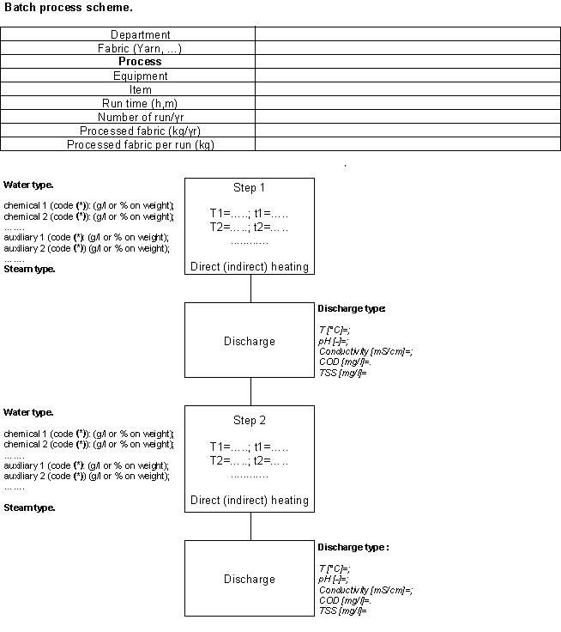
Figure 1 – Batch process scheme

Processes used as facilities (filtration, softening, demineralisation, steam production) are analysed the same way as manufacturing processes.
Water and pollution load (COD) mass balances are elaborated according to production model and process schemes. This leads to the identification of the weight which processes contribute to the total water usage and discharge relating to the type and quantity of manufactured textile as well as to the total pollution load.
Other environmental information, such as solid waste, discharge treatments, energy consumption, gas emissions and age of used equipment (intended as applied technology degree) are reported because of its importance regarding to the environmental impact as a whole.

The PIDACS data are used for the development of other workpackages related to water pinch analysis, LCA, characterisation and design of wastewater and waste water treatment.

Scientific achievements (case studies in the synthetic fibres and silk industries)
According to WP1 results ("Qualitative survey on GEP application in the textile finishing industries"), five industries of Como area have been chosen to represent the textile district most important manufacturing, as reported in the Table 1 below.
Each company, identified by an alphanumerical code, is mainly devoted to the manufacturing of a specific fibre, indicated as well in the table.

Table 1: The selected five industries in Como textile district
Company code | Type of mill | Manufactured fibre | Type of fibre | Market segment
I06 | Dyeing | PES | fabric | interior textile
I09 | Dyeing | SILK | Yarn | clothing - interior textile
I02 | Printing | VISCOSE | fabric | clothing textile
I15 | dye-printing | SILK | fabric | clothing - interior textile
I04 | Dyeing | VISCOSE | fabric | clothing - interior textile

The methodology for "Process Identification and DAta Collection Sheet" was applied to the five companies obtaining several interesting data on single textile process and on production chain.
The main conclusions from the data collection can be summarised as reported in the Table 2.

Table 2: Department water consumption and organic load
Department | Water consumption  (% of company total consumption) |  |  | Organic load  (% of company total organic load)
 | max. | average | min. | max. | average | min.
General Facilities | 6 | 14 | 33 | 0,1 | 2 | 8
Preparation | 16 | 36 | 54 | 45 | 61 | 77
Dyeing | 4 | 29 | 53 | 4 | 23 | 47
Printing | 42 | 55 | 38 | 42 | 59 | 75
Steaming | 0,3 | 0,4 | 0,6 | 0,0 | 0,1 | 0,1
Fabric washing | 3 | 28 | 52 | 1 | 13 | 25
Finishing | 0,3 | 1 | 4 | 0,1 | 3 | 7

In Table 3, 4 and 5 are reported the measured values, related to the values estimated by PIDACS application.

Table 3: Comparison of measured and estimate values of water consumptions
Company | Water consumption m3 (measured) | Water consumption m3 (estimated) | Difference on measured value m3 | Difference on measured value %
I06 | 93264 | 94035 | +771 | +0,82%
I09 | 291568 | 291570 | +2 | 0,00%
I02 | 137575 | 137636 | +61 | +0,04%
I15 | 575384 | 564279 | -11105 | -1,9%
I04 | 579887 | 581256 | +1369 | +0,2%

Table 4: Comparison from measured and estimate values of water discharges
Company | Water discharges m3 (measured) | Water discharges m3 (estimated) | Difference on measured value m3 | Difference on measured value %
I06 | 85295 | 85599 | +304 | +0,36%
I09 | 267619 | 266608 | -1011 | -0,38%
I02 | 132014 | 131996 | -18 | -0,01%
I15 | 525183 | 514078 | -11105 | -2,1%
I04 | 538988 | 524226 | -14762 | -2,6%

Table 5: Comparison from measured and estimate values of COD concentration
Company | COD concentration mg/l (measured) | COD concentration mg/l (estimated) | Difference on measured value mg/l | Difference on measured value %
I06 | 931 | 1097 | +166 | +17,8%
I09 | 1600 | 1872 | +272 | +17%
I02 | 967 | 1112 | +145 | +15%
I15 | 627 | 721 | +94 | +15%
I04 | 835 | 850 | +15 | +1,8%

The values of estimated water consumptions and water discharges are the same as the measured ones, while the COD concentration is overestimated.

Scientific achievements (case studies in the cotton industries)
Based on the results of WP1 (Qualitative survey on GEP application in the textile finishing industries), five companies have been selected to represent the Flemish textile industry finishing cotton and mixtures of cotton with all kind of synthetic fibres. In table 6 an overview is made of the alphanumerical code and the activity of the company, i.e. type of fibre, make-up and market segment of the end product.

Table 6: Selected Flemish companies
Company code | Type of mill | Manufactured fibre | Make-up | Market segment
B01 | pre-treatment/dyeing/finishing | cotton, wool, viscose, polyester: pure and mixtures | yarn/fabric | commission finisher
B02 | pre-treatment/dyeing/finishing | cotton, polyester/cotton | yarn/fabric | clothing textiles
B03 | pre-treatment/dyeing-printing/finishing | polyester/cotton, polyamide/cotton | fabric | clothing textiles
B04 | pre-treatment/dyeing/finishing | cotton | yarn/fabric | clothing - interior textiles
B05 | pre-treatment/dyeing/finishing | cotton, mixtures of cotton with polyester, polyamide, flax, wool, viscose | fabric | clothing and technical textiles

In table 7 the water consumption and discharge is mentioned for each of the participating companies. Based on the amount of textile finished, the specific water consumption is calculated. This varies between 26.6 l/kg and 80.4 l/kg. Companies processing the textile mainly via continuous lines have a lower specific water consumption than companies specialised in batch processes.

Table 7: Water consumption and discharge in the Belgian companies
company | manufactured fibre | water consumption (m³) | water  discharge (m³) | specific water consumption (l/kg)
B01 | cotton, wool, viscose, polyester: pure and mixtures | 857 839 | 754 898 | 69
B02 | cotton, polyester/cotton | 396 510 | 294060 | 26.6
B03 | polyester/cotton, polyamide/cotton | 389257 | 299541 | 68.7
B04 | cotton | 588344 | 489638 | 80.4
B05 | cotton, mixtures of cotton with polyester, polyamide, flax, wool, viscose | 500000 | 330228 | 47.6

In Table 8 are reported the values of COD concentration for the five companies, related to the values estimated by PIDACS application.

Mostly the estimated value is lower than the measured one, however the differences are rather low (in all cases lower than 20%). Only for B03 the estimated value was double the measured concentration. This can be explained by the fact that for the measuring campaign mostly highly concentrated streams have been sampled and analysed. These results have been used for the calculation of the estimated COD concentration.

Table 8: COD concentration in discharged effluent
company | COD (mg/l)  measured | COD (mg/l)  estimated | difference (mg/l)  estimated - measured | difference (%)  estimated - measured
B01 | 700 | - | - | -
B02 | 5500 | 5144 | -356 | -6.9
B03 | 1046 | 2376 | 1330 | 56
B04 | 2250 | 1890 | -360 | -19
B05 | 2000 | 1940 | -60 | -3

The process data gathered in the PIDACS are grouped together to resume the specific water consumption and the specific COD load caused by a specific process.

In table 9 values are gathered concerning the pre-treatment of both pure cotton and mixtures of cotton and synthetic fibres like polyester and polyamide. The pre-treatment of cotton is mostly a combination of bleaching with desizing or boiling. In most of the Belgian companies pre-treatment of cotton is done on continuous lines, since the water consumption is lower and the impurities of the textile material are very efficiently removed. The COD load generated in the pre-treatment process is only for a minor part related to the dosed chemicals. The biggest part of the discharged COD is caused by the impurities of the cotton, the sizing agent and the spinfinishes on the natural and synthetic yarns. The higher the specific COD load, the more impurities removed from the fabric/yarn.

The mercerisation of cotton or cotton/polyester has a very low specific COD load since the most important product used in this process is NaOH. The COD load is caused by some additional removal of impurities of the cotton.

The specific COD load generated by degreasing polyester is linked to the amount of spinfinish present on the polyester.

Table 9: Average values for pre-treatment
fibre type | pre-treatment | process | specific water consumption  l/kg textile | specific load  g COD/kg textile
CO | desizing/boiling  desizing/bleaching | continuous | 8 | 122
CO | desizing/bleaching | continuous | 20 | 52.7
CO | desizing/bleaching | continuous | 14 | 51.2
CO | mercerising | continuous | 10 | 5
CO/PES | bleaching | continuous | 14 | 52.8
CO/PES | mercerising | continuous | 10 | 5
PES, PA, CO/PES, CO/PA | desizing: PA, PES  bleaching: CO | continuous | 25.6 | 34
PES | degreasing | batch | 10 | 64

In table 10 the data for vat dyeing of cotton are listed. Both the specific water consumption and the specific load show very high variations. Normally the continuous dyeing of fabric has a lower water consumption than the batch process. In the participating companies such a process was not executed. The continuous dyeing of yarn on the other hand is a very specific process, done in only one company in Belgium. The choice for this process is determined by the end product. The water consumption for this process is comparable to the continuous dyeing of fabric with vat dyestuff.

Table 10: Average values for vat dyeing of cotton
process | make up | specific water consumption  l/kg textile | specific load  g COD/kg textile
continuous | yarn | 25.7 | 66
batch | yarn | 53 | 39.5
continuous | fabric | 10 | 18.5
continuous | fabric | 65 | 103
continuous | fabric | 21.7 | 41

In table 11 some data are listed of the dyeing of cotton with specific vat dyestuff: i.e. indigo and sulphur dyes. All the data are related to continuous processes. Depending on the desired colour the dyeing of cotton yarn can be done with indigo or sulphur dyestuff. This has a considerable impact on the specific COD load, i.e. 32 g COD/kg textile for indigo and 86 g COD/kg textile for sulphur dyeing. Moreover the waste water of an indigo dyeing is much better biodegradable. The textile companies however have no impact on the trends in the market and are obliged to follow the demands of their clients.
The continuous dyeing of fabric with sulphur dyestuff has a considerable lower specific water consumption than the sulphur dyeing of yarn, also the specific COD load is significantly lower. The company is however obliged to perform the continuous dyeing of yarn with sulphur dyes for obtaining the desired end quality of the produced textile material.
Table 11: Average values for indigo and sulphur dyeing of cotton
type of dyeing | process | make up | specific water consumption  l/kg textile | specific load  g COD/kg textile
Indigo | continuous | yarn | 25.7 | 32
Sulphur | continuous | yarn | 25.7 | 86
Sulphur | continuous | fabric | 10 | 45.9

Table 12 resumes some of the data gathered in the PIDACS concerning the dyeing of cotton with reactive and direct dyestuff. The batch dyeing of cotton yarn with reactive dyestuff has a very low specific COD load in comparison to the data of continuous processes, i.e. 39.5 g COD/kg textile in comparison to more than 80 or even 185 g COD/kg textile.

Table 12: Average values for direct and reactive of cotton
type of dyeing | process | make up | specific water consumption  l/kg textile | specific load  g COD/kg textile
Reactive | batch | yarn | 53 | 39.5
Reactive | continuous | fabric | 65 | 103
Reactive | continuous | fabric | 17.9 | 185
Direct | continuous | fabric | 10 | 82

In table 13 a variety of data are listed together. Synthetic fibres are in the participating companies for a minority treated pure. They are mixed mostly with cotton, many combinations are created in recent times. Each of them offering specific advantages and aspects to the finished textile end-product. The specific water consumption and COD load for the batch dyeing of PES and PA has the same order of magnitude as the printing of PA and PES with disperse, acid dyestuff and pigments on a continuous printing line. As expected the water consumption is lower (continuous versus batch process), i.e. 30 l/kg versus 56 l/kg. The COD load generated for printing is to a big extent due to the cleaning of the rubber transport band and the barrels.
Comparing the data for dyeing of synthetic fibres in batch and continuous mode, confirm the general conclusion: continuous processes consume much less water (11.8 l/kg versus 56.4 l/kg) and moreover in this case also the specific COD load is significantly lower. The origin of the material and the type of chemicals already present on the textile determine to a big extent the COD load generated.

Table 13: Average values for synthetic fibres
fibre type | type of treatment | process | specific water consumption  l/kg textile | specific load  g COD/kg textile
PES | disperse dyeing | batch | 30 | 51
PES/CO | disperse/vat dyeing | continuous | 23.3 | 13.6
PA, PES | disperse, acid and metal-complex dyeing | batch | 56.4 | 171
PES, PES/CO, CO, PA/CO | disperse, reactive, vat and acid dyeing | continuous | 11.8 | 13.8
PES/CO, PES, PA | printing with pigments, acid and disperse dyestuff | continuous | 30 | 118

Main deliverables
D4- D6 Material and resources data input
D5-D7 Report on quantitative evaluation of GEP

Effluents characterisation and design

Methodology
A respirometric technique was developed based on the measurement of the dissolved oxygen consumption rate by activated sludge degrading components in textile process wastewater. The technique consists of adding repeatedly samples of defined substrates and wastewater to activated sludge in a small test reactor, and measuring the oxygen uptake rate using a respirometer. Respirometry was used to assess the aerobic degradability of the wastewaters, their treated effluents (anaerobically, UF, NF) and their concentrates. The degradability was evaluated from the respirograms and was represented by the short-term biochemical oxygen demand (BOD_{ST}).

Isothermal direct calorimetry has been applied to investigate aerobic biodegradability of mixed final effluents from two textile factories. For this purpose a bench scale calorimeter (Bio-RC1) especially modified for biological studies and equipped with a dissolved oxygen probe has been used. The latter was used to derive oxygen consumption (respiration) rate profiles. Through pulses of selected substrates (textile wastewaters, acetate or ammonia) aerobic metabolic activity has been assessed for heterotrophic and autotrophic nitrifying bacterial populations in sludge samples from wastewater treatment plants treating domestic and/or textile effluents. Calorimetric data (thermograms) have been compared to the respirometry data obtained simultaneously, so that wastewater degradation has been characterised in terms of microbial heat dissipation and short-term biochemical oxygen demand.

Infrared spectroscopy was used to determine the chemical oxygen demand (COD) of wastewater samples. A calibration procedure was worked out that was targeted at the specific characteristics of the textile wastewaters. A number of samples were analysed using the infrared technique at the Laboratory of Biotechnology and Environment of INRA Narbonne, France. Although based on only a few samples. the results of this experiment indicate the possibility of using infrared spectroscopy for measurements of COD in textile wastewater.

The combination of the short-term BOD value (biochemical characteristic) and the COD value (physical/chemical characteristic) in a BOD_{ST}/COD ratio was used as a measure of the treatability of a wastewater. A complete scheme for the on-line biological treatability measurement is given in Figure 2.

Figure2: Scheme for on-line biological treatability measurement.

The textile wastewater sample is taken directly after it leaves the textile processing equipment. It is passed on to both a respirometer and an infrared spectrometer. From the infrared spectrum the COD value is derived, and from the respirogram the short-term BOD value. With those two values the BOD_{ST}/COD ratio is calculated. Because the BOD is always lower than the COD, this value lies between 0 and 1. It is a measure of the treatability of the wastewater: the higher the ratio, the better treatable the wastewater. Based on this ratio a decision can be taken on where to send the wastewater for treatment. Other characteristics (such as wastewater toxicity) that can be obtained from the respirogram can also be used in the decision for a treatment option. Examples of respirograms and infrared spectra are given in Figure 3 and 4 respectively.

The respirogram on the right shows that the wastewater sample was (partly) degradable, as a response can be seen: Upon addition of the sample at t=0 the respiration rate (R) increases from around 7 mg O₂/l.h to around 11 mg O₂/l.h. After processing the degradable fraction (around t=30), the respiration rate keeps dropping until well below the initial rate of around 7 mg O₂/l.h, which indicates a toxicity effect. Part of the biomass was affected by the sample, and because the affected biomass does not consume the oxygen, the respiration rate drops. This information is useful when deciding how to treat a wastewater. Infrared spectra are used for COD determination. As no biomass is involved in those measurements, no extra information could be obtained. Calibrating the infrared method for detection of other wastewater constituents is possible, but whether or not this is possible depends entirely on the wastewater.

Figure 3: Respirograms. Example of a well degradable substrate (left) and a toxic substrate (right).

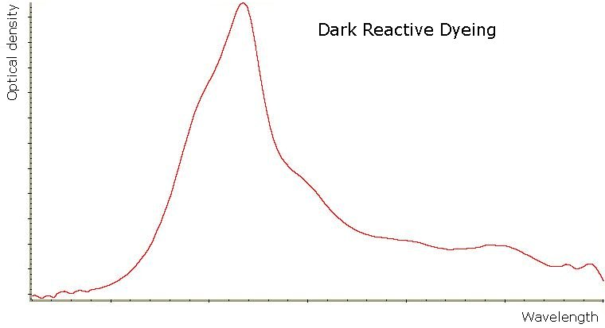 | 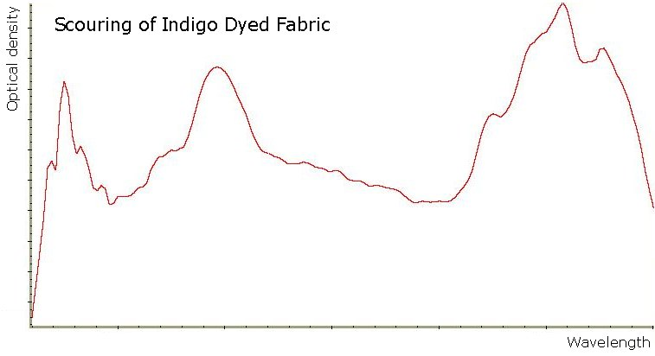
Figure 4: Examples of infrared spectra for COD assessment. Dark reactive dyeing (left) and scouring of indigo dyed fabric (right).

The difficult part of on-line respirogram analysis is the automated detection of the end-point of the part of the respirogram that belongs to the reaction of a sample. A trained expert can analyse respirograms simply by looking at them, and is able to identify the endpoint. When looking at a respirogram, an expert uses a lot of (subjective) background information obtained from analysing other respirograms. To develop an automated analytical procedure to judge respirograms is a very difficult task.

In an attempt to overcome these problems, tests were performed using an artificial neural network. Neural nets are suitable for complex analysis that have a highly pluriform input. They consist of a number of artificial neurons that are all connected, with weights to determine the importance of each neuron (see Figure 5).

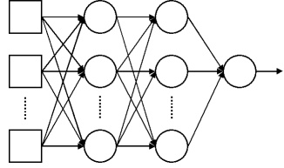  A  B  C  D | Figure 5: Block diagram of a two hidden layer multiplayer perceptron (MLP). The inputs are fed into the input layer (A) and get multiplied by interconnection weights as they are passed from the input layer to the first (B) and second (C) hidden layer, and finally to the output layer (D) to produce the neural network output.

The neural network can be trained, it can ‘learn’ to get the desired outcome when trained with a large enough number of examples. Respirograms and their endpoints were fed to the network for training. Different combinations of numbers of neurons and sets of respirograms were evaluated.

Scientific achievements
A satisfactory agreement was observed between respirometric profiles and calorimetric power-time curves confirming that under strictly aerobic conditions respirometry and calorimetry provide the same information (Figure 6). Oxycaloric equivalent, defined as the amount of heat released by the culture per mole of oxygen consumed, was estimated when textile wastewaters were the sole exogenous substrate. The values obtained are close to the theoretical value for heterotrophic aerobic metabolism (460 kJ mol⁻¹O₂) and to literature data. Additionally, toxicity effect on microbial communities due to raw wastewater additions has been successfully investigated.
Figure 6: Comparison between respiration rate (smooth line) and heat production rate (noisy line) profiles simultaneously acquired after addition of raw wastewater to activated sludge biomass.

Respirograms and COD analyses have been performed on a series of dyeing wastewater samples coming from the different steps of the process. Due to very low concentrations in most of the samples from rinsing steps, not all results could be used in the tests with the neural network. The neural network used (MatLab NNW toolbox) proved capable of determining the endpoints of respirograms. Although the endpoints predicted by the neural network sometimes differed considerably from the manually determined endpoints, the resulting calculated BOD_{ST} was usually quite exact. Table 14 shows the result of one of the tests.

Table 14: Example results of BOD_{ST} assessment by means of neural network.
Respirogram | End point |  |  | BOD_{st} (mg/l)
 | Manual | NNW | Δ | Manual | NNW | %
Acid dyeing 52 | 55 | training | - | 184 | training | -
Acid dyeing 203 | 95 | training | - | 340 | training | -
Acid dyeing C | 81 | training | - | 334 | training | -
Bleaching | 86 | training | - | 2407 | training | -
Size | 85 | training | - | 2866 | training | -
Light reactive dyeing | 106 | training | - | 157 | training | -
Silk degumming | 71 | training | - | 685 | training | -
Acid dyeing 106 | 51 | 65 | -14 | 222 | 227 | 102
Indigo cotton scouring | 74 | 78 | -4 | 1950 | 1982 | 102
Black sulphur dyeing | 58 | 80 | -22 | 2528 | 2457 | 97
Silk degumming 2 | 71 | 61 | 10 | 788 | 741 | 94
Dark acid dyeing | 69 | 68 | 1 | 792 | 790 | 100
Dark acid dyeing 2 | 80 | 89 | -9 | 787 | 814 | 103
Dark reactive dyeing | 82 | 89 | -7 | 359 | 349 | 97

The first seven rows of the table show the manually detected endpoints and concomitant BOD_{ST} values of various wastewater samples, used for training. The remainder shows the BOD_{ST} values by the neural network. In percentages is indicated how the NNW-determined BOD_{ST} relates to the manually determined values. For this set of samples the BOD_{ST}/COD ratio was calculated to get an indication for their treatability. Results are presented in Table 15.

Table 15: Examples of calculated treatability expressed as BOD_{ST}/COD and in terms of an alternative indication.
Respirogram | BOD_{ST} | COD | BOD_{ST}/COD | Treatability
 | (mg/l) | (mg/l)
Acid dyeing 106 | 227 | 5244 | 0.04 | – –
Indigo cotton scouring | 1982 | 11574 | 0.17 | –
Black sulphur dyeing | 2457 | 6027 | 0.41 | + +
Silk degumming 2 | 741 | 3400 | 0.22 | +
Dark acid dyeing | 790 | 2300 | 0.34 | + +
Dark acid dyeing 2 | 814 | 2300 | 0.35 | + +
Dark reactive dyeing | 349 | 2660 | 0.13 | –

Although a demonstration set-up of the on-line technique could not be tested in a textile factory, everything indicates that it should be possible to install the used respirometer and infrared spectrometer on-site for automatic measurement and analysis.

Main deliverables
D10: An on-line textile wastewater characterisation technique. Includes D13: A protocol to determine the optimum composition of the wastewater streams of the different process units.
D11: A Framework for the Application of calorimetry in the characterization of biological textile wastewater treatment process.

Effluents treatment

Methodology
After a full analysis of the production processes and after having performed a detailed characterisation of the wastewaters, a proper treatment had to be selected for the streams. The proper treatment technology to really allow for the production of reusable effluents and for the effective integration with production processes has to comply the following requirements: high removal of colour, organics and where needed salts, constant effluent quality, automatic operation and control, low weight and space, modularity, capability of dealing with small and intermittent water flows and reliability as required to be BAT. All considering, membrane filtration was selected as the most suitable technology.
Membrane treatment tests were performed on 17 different raw process effluents + 2 anaerobically pretreated. They were selected by focusing on the most important effluent streams in the textile finishing industries as resulted from the analysis of the companies involved in the project. Water using departments contribute to the total wastewater production as follows:
- General Facilities department accounts normally for a significant fraction of wastewater production but the discharged organic load is negligible;
- Preparation, dyeing and printing departments represent by far the most important wastewater producing processes and the related waste streams account for the biggest fraction of organic load discharged in the final company effluent.
- Finishing department involves normally low wastewater amounts and organic load production.
All this considered, the effluents tested were selected among preparation, dyeing and printing operations on natural and artificial fibres.
The streams tested are characterized by high variability in the dissolved organic carbon (DOC) as well as in colour and salinity (Table 16).

Table 16: Characterisation of process effluents tested
Process | DOC  mg l⁻¹ | Colour Abs (cm⁻¹) |  |  | Cond.  μS cm⁻¹
Process | DOC  mg l⁻¹ | 426nm | 558nm | 660nm | Cond.  μS cm⁻¹
Polyester scouring | 481 | 0.012 | 0.004 | 0.004 | 544
Polyester double scouring | 737 | 0.128 | 0.068 | 0.047 | 552
Polyester scouring rinsing | 16 | 0.004 | 0.002 | 0.004 | 75
Polyester disperse dyeing | 300 | 0.093 | 0.019 | 0.005 | 747
Polyester disperse dyeing rins. | 16 | 0.005 | 0.001 | 0.002 | 197
Polyester printed wash. | 305 | 0.092 | 0.023 | 0.011 | 1096
Polyester disperse print | 57 | 0.005 | 0.001 | 0.002 | 570
Viscose direct dyeing rinsing | 1 | 0.007 | 0.001 | 0.004 | 745
Viscose reactive printed wash. | 700 | 0.393 | 0.330 | 0.153 | 1223
Silk polymer charge | 5699 | 0.006 | 0.005 | 0.001 | 2440
Silk scouring | 840 | 0.056 | 0.024 | 0.015 | 617
Silk scouring rinsing | 136 | 0.016 | 0.008 | 0.008 | 149
Silk yarn reactive dyeing | 775 | 2.813 | 3.939 | 0.022 | 39800
Silk acid dyeing rinsing | 33 | 0.019 | 0.022 | 0.009 | 1619
Polyamide Acid dyeing | 480 | 1.402 | 1.693 | 1.567 | 830
Cotton Reactive dyeing | 120 | 0.466 | 0.355 | 0.151 | 16800
Cotton Bleaching line | 401 | 0.022 | 0.01 | 0.009 | 1670

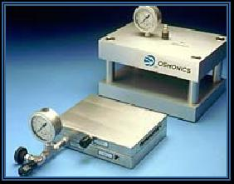
Several membranes were tested for ultrafiltration treatment (UF in the following), for nanofiltration (NF) and reverse osmosis (RO) to select the proper membrane for each
effluent.  The tests for membrane selection were carried out on SEPA CF by Osmonics (see Figure 7) a bench equipment that mimics the operating conditions of a spiral wound membrane element.  Tests were carried out on real effluent samples (5 l) by flat sheet membranes of 190x140 mm in conditions of complete recycling of permeate and concentrate (cross-flow velocity: 0.10 m s⁻¹). | Figure 7: Bench scale equipment

The selection was based on the contaminants rejection values, on the membrane/effluent interactions and on the permeate flux values.

According to the different characteristics of the effluents, the following treatment configurations were tested on pilot scale (Figure 8) using spiral wound polymeric membranes (diameter 4.6 cm, length 30.5 cm, membrane surface 0.3-0.4 m²):
- UF and UF + NF: Polyester scouring, Polyester double scouring, Polyester disperse dyeing, Polyester printed washing, Polyester disperse printing, Viscose reactive printed washing, Silk polymer charge, Silk scouring, Silk yarn reactive dyeing, Polyamide Acid dyeing, Cotton Reactive dyeing and Cotton Bleaching line.
- Direct NF: Viscose reactive printed washing, Polyester scouring rinsing, Polyester disperse dyeing rinsing, Viscose direct dyeing rinsing, Silk scouring rinsing, Silk acid dyeing rinsing.
- UF +RO: Polyester scouring, Polyester double scouring, Polyester disperse dyeing, Polyester printed washing.

All the tests consisted in the following steps:  - Characterisation using de-ionised water, measuring the fluxes at various temperatures (25–45°C) and pressures in operating range to obtain the maximum values achievable.  - Test on real effluents in batch (25 l), recycling concentrate and permeate, measuring the flux decay after 60 min and performing a full characterisation of the permeate sampled.  - Test on real effluents in batch (25 l), recycling concentrate and discharging permeate, measuring fluxes and characterising samples at increasing feed concentration (volume reduction of 20%, 40%, 60% and 80%).  - Characterisation using de-ionised water after the treatment tests. | 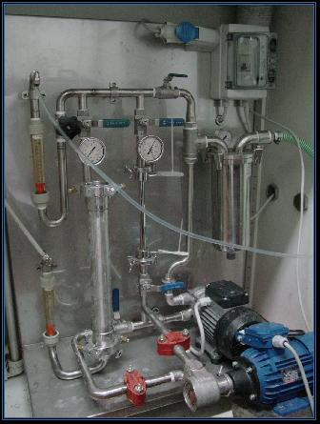  Figure 8: Pilot scale plant

The results were elaborated to obtain operational parameters and to make technical economical evaluations. Based on permeate flow rate values, measured during the four steps of tests, the following parameters were calculated:
- Membrane/effluent affinity: the flow rate decrease passing from pure water to real effluent filtration; it is index of compounds affecting the membrane performance (e.g. compounds increasing the polarisation of the membrane).
- Recovery index: the percentile loss of flow rate at increasing feed concentrations; it determines the level of recovery obtainable (i.e. how much volume of permeate can be obtained as a percentage of the feed volume).
- Fouling tendency: percentile loss of filtration flow rate between the first and second characterization; it indicates permanent fouling of the membrane surface and it is used to evaluate the hours of plant operation before the need of chemical washing.
The parameters values give indications on the operative conditions for a preliminary full scale treatment design. These indications include: total membrane surface, permeate flux, permeate recovery, washing frequency. The treatment design was carried out for each effluent taking into account: treatment plants complete of sand filtration, membrane filtration and washing equipment, installation cost, commercial spiral wound modules 25 m² (UF) and 32 m² (NF and RO), chemicals and energy costs. The calculation was carried out in four different scenarios of company size (plant treatment capacity ranging from 10000 to 250000 m³/year).

To evaluate alternative ways of treatment, effluents with important colour and organic content were also tested in anaerobic reactors, as pre-treatment step for membrane filtration. Three lab scale UASB and two EGSB anaerobic reactors (Figure 9) were constructed and equipped with the necessary pumps, gas meters and containers for wastewater and effluent. Various process effluents (from sizing, scouring, bleaching and various dyeing operations) were sampled in textile factories and were treated in the reactors under different operation regimes (loading and retention time). Reactor performance was monitored by means of effluent and biomass analysis and gas production rate measurements.

Figure 9: Bioreactors used for anaerobic tests: UASB (left). EGSB (right).

The scouring. bleaching and black sulphur dyeing wastewaters were only tested in batch experiments for their biodegradability, whereas the sizing wastewater was treated in both batch mode and UASB reactor and it was investigated in terms of biodegradability under various operating conditions. Cotton reactive dyeing and Polyamide acid dyeing effluents were treated in EGSB type reactors, as pre-treatment step for membrane filtration.

For the final disposal of the wastewaters produced, when separation technologies are applied for reuse, evaluations of aerobic treatability were carried out on raw effluents and on the concentrates produced by their treatment. Even if acceptable in terms of concentration of pollutants, the streams have to be assessed in terms of the potential impact on the existing WWTP. The textile wastes contain poorly degradable organics and often toxicants that are concentrated in membrane retentates. To preliminary confirm of the feasibility of concentrates disposal in traditional WWTPs, a methodology was set up to measure the inhibition of the nitrifying activity of the concentrates and these results were combined with the biological treatability evaluated by BOD₅/COD ratio.
The nitrifying sludge used is prepared according International Standard ISO 9509 1989 (E). The sludge. in a solution with nutrients and ammonia. is aerated and maintained at constant pH by automatic titration using alkaline and acid solutions in thermostatic chamber (21.5 °C ±0.1)
The specific nitrifying activity (v = mg N-NH4 (gSSV h)-1) without inhibition is measured by measuring the titration flow rate (mC0). The potentially toxic effluent is added at increasing doses measuring mCi. The percentage inhibition is calculated as:

m(ATU) = titrating flow rate with totally inhibited nitrification.

Scientific achievements
The main results of the overall experimental activity are briefly discussed in the following.

The UF treatment alone does not normally assure a quality of the permeates suitable for undifferentiated reuse. Permeate flows are high (typically 100 - 150 l h⁻¹ m⁻²) and costs are affordable (typically 0.30 - 0.40 Euro/m³ in the hypothesis of 50,000 m³/year of water to be treated) but organics and colour removal are variable and conductivity is not affected.

NF resulted to be the best compromise between the need of having high flow rates (consequently reducing treatment costs) and good quality permeates. Permeate flow ranges between (30 and 60 l h⁻¹ m⁻²). Colour is almost completely removed and residual values never affect the reusability. Salinity abatement is variable and in the effluents of certain dyeing operation (i.e. reactive dyeing of silk and cotton), where monovalent salts are used heavily, the removal is low and it prevents the reuse. The removal of organic matter is high, nevertheless effluents with a high organic content (DOC> 400-500 mg l⁻¹) give permeates normally not reusable. Removals obtained for each effluent in NF filtration is shown in Figure 10.
Figure 10: Average removal of organic content (measured as Dissolved Organic Carbon), colour (measured as absorbance on 1 cm optical path at 426nm wavelength) and salinity (measured as conductivity) obtained in pilot plant with 80% recovery.

Direct NF treatment resulted feasible only on the most diluted effluents of rinsing operations. Percentage removals in these cases are lower but sufficient to produce a permeate reusable in any process. Costs are also promising, ranging between 0.55 and 0.68 Euro/m³. (see Figure 11)
The treatment configuration UF + NF seems in most cases technically and economically feasible except for the silk polymer charge, polyester double scouring and cotton bleaching line which evidenced very low permeate fluxes and/or relevant material accumulation on the membrane surface. The cost range is 0.67 –0.83 Euro/m³. (see Figure 11)

Figure 11: Costs calculated for NF and UF+NF treatment in a scenario of 50000 m3/year of effluent to be treated

RO treatment of the tested effluents always required an UF pre-treatment and despite the very high removal of contaminants, it resulted to be scarcely promising because of the very low fluxes (<10 l h⁻¹ m⁻²) and, consequently, high costs (1,60-2,90 Euro/m³).

The anaerobic batch tests showed that for sizing wastewater more than 90% of the COD was degraded. The anaerobic biodegradability of dyeing, scouring and bleaching wastewaters appeared to be affected by pH and constitution of nutrient solution. Organic matter in scouring and bleaching wastewaters was converted mainly to acetate, propionate and butyrate but not into methane, resulting in significant accumulation of VFA in the medium. The anaerobic biodegradability of scouring and bleaching is most dependent on its initial COD concentration. The COD total removal efficiency is lower at the higher COD concentration. As an example, Figure 12 shows the course of the biodegradation of sizing wastewater during batch test.

Figure 12: Anaerobic biodegradation of sizing wastewater, measured as COD concentrations.

In UASB reactor sizing wastewater was highly biodegradable at loadings of 3.2, 4.0 and 4.8 kg COD/m³ day. The optimum hydraulic retention time was 12 hour with removal efficiency above 85% and 80% of the COD was converted to methane. However. a small fraction of lipids in wastewater occasionally caused part of the sludge bed to float. The floating sludge occurred at HRT 8 hour. In order to overcome the problem, HRT or velocity (very high EGSB conditions) should be increased to completely degrade lipids into methane. The Figure 13 shows the anaerobic granules covered with a layer of lipid from the sizing water.
Figure 13: Anaerobic granules covered with lipids

Scouring and bleaching wastewaters show highest toxicity towards anaerobic microorganisms. The sizing wastewater has a high COD (64 kg.m-3) that is mainly due to the high starch and fat content. Sludge flotation problems occurred in the continuous UASB reactor tests one week after start of operation. This was probably caused by the degradation of fat leading to long chain fatty acids (lipids) that covered the sludge granules resulting in flotation. Stopping circulation and application of a low flow solved the problem.
Anaerobic treatment of the dyeing wastewaters in EGSB reactors was possible. Good colour removal was obtained in the non-optimised systems used in the experiments. Optimisation of the anaerobic reactor system was not possible within this stage of the project. Respirometry was used to assess the aerobic degradability of the wastewaters, their treated effluents (anaerobically, UF, NF) and their concentrates. Anaerobic pre-treatment did not lead to an improved membrane treatment in terms of removal efficiencies, but might be a way to achieve that membrane concentrates are aerobically degradable in a conventional (activated sludge) wastewater treatment system.

Curves of inhibition on nitrifying activity were calculated on feed, UF concentrate and NF concentrate, produced by the membrane treatment of various textile effluents. From the inhibition curves, the EC₅₀ values, representing the volume of effluent per gram of biomass able to reduce by 50% the nitrifying activity, were extrapolated. The results obtained coupled with BOD₅/COD ratio values (index of biodegradability) are reported in Table 17.

Table 17: EC₅₀ and BOD₅/COD ratio values measured in the effluents and membrane concentrates
L:V: Too low values of organic matter to allow for reliable calculations

Combining the inhibitory effect with the biodegradability, the silk reactive dyeing effluent seems scarcely biologically treatable being high in toxicity and low in biodegradability. As for cotton bleaching line, the treatability is not very promising, while silk scouring showed very good properties. The viscose reactive printed washing effluent, even if potentially toxic, is highly biodegradable, it could therefore be successfully treated in WWTP if dosed in opportune quantity. The concentrates from UF treatment of these effluents did show better treatability of the raw effluents, while NF concentrates are normally more toxic.
As for the evaluation of concentrates toxicity of the rinsing effluents, the results obtained, gave a preliminary confirmation of the feasibility of final wastewaters disposal in traditional WWTPs.

Main deliverables
D 15: Operational data to design treatments
D 16: Protocol for the evaluation of treatability

Effluents reuse
Based on the data collected in the companies (PIDACS) and on the results of the Water Pinch, textile processes in each of the participating companies were selected, whose waste water could be treated and re-used for the same or for another process (see Table 18 and 19).

Table 18: Pretreatment: samples collected, treatment and reuse tests performed
Fibre used for tests | Process sampled | Step | Wastewater treatment | Pretreatment performed | Efficiency tests
PES | Scouring at 60°C | Rinsing | Nanofiltration | Scouring | Scouring efficiency  Degree of whiteness
SILK YARN | HT scouring | Rinsing | Nanofiltration | Degumming  Polymer charge | Degumming efficiency  Charge efficiency
SILK FABRIC | Dark acid dyeing | Rinsing | Nanofiltration | Degumming | Degumming efficiency  Degree of whiteness
VISCOSE | Dark direct dyeing | Rinsing | Nanofiltration | Scouring | Scouring efficiency  Degree of whiteness
COTTON | bleaching | Bleaching + rinsing | Ultrafiltration + nanofiltration | Bleaching | Degree of polymerisation  Degree of whiteness

Table 19: Dyeing: samples collected, treatment and reuse tests performed
Fibre used for tests | Process sampled | Step | waste water treatment | Dyeing processes performed
PES | Scouring at 60°C | Rinsing | Nanofiltration | Light disperse dyeing  Dark disperse dyeing
PES | Medium disperse dyeing | Rinsing | Nanofiltration | Light disperse dyeing  dark disperse dyeing
PES | Disperse printing | Rinsing | Ultrafiltration + nanofiltration | Light disperse dyeing  dark disperse dyeing
SILK YARN | HT scouring | Rinsing | Nanofiltration | Light acid dyeing  Dark acid dyeing
SILK FABRIC | Dark acid dyeing | Rinsing | Nanofiltration | Light acid dyeing  Dark acid dyeing
PA | Dark acid dyeing | Mixed sample: dyebath + rinsing | Ultrafiltration + nanofiltration | Light acid dyeing  Dark acid dyeing
VISCOSE | Dark direct dyeing | Rinsing | Nanofiltration | Light direct dyeing  Dark direct dyeing  Light reactive dyeing  Dark reactive dyeing
COTTON | Bleaching | Mixed sample: bleaching + rinsing | Ultrafiltration + nanofiltration | Light direct dyeing
COTTON | Reactive dyeing | Mixed sample: dyebath + rinsing | Ultrafiltration + nanofiltration | Light direct dyeing  Dark direct dyeing  Light reactive dyeing  Dark reactive dyeing

The objective of the treatment was to obtain a water quality comparable to fresh process water and it was pursued by using the membrane nanofiltration technology (in some cases coupled with ultrafiltration pretreatment). Permeates of the NF and UF/NF pilot scale treatment were selected for the re-use tests.

The re-use tests were performed on lab scale: pre-treatment and dyeing processes both on yarn and fabric. The recipes for the tests were agreed upon by the participating companies. To be able to evaluate the treated textile material, a reference test was carried out with fresh process water.
The re-use options of the different permeate streams were tested both with 100% permeate or with a combination of permeate and fresh process water. In a full scale operation it is advisable to dilute the permeate to avoid an increased concentration of some of the components. Membrane filtration results always in a permeate and a concentrate streams, which means that fresh process water is anyhow necessary to compensate the loss of water to the concentrate discharge.
Using a 100% permeate solution for the re-use tests on the other hand is simulating a worst case scenario and is somehow a compensation for the fact that the re-use cycle has only been performed once, i.e. production of waste water, treatment and re-use.
The pre-treated and/or dyed fabric or yarn has been compared with the quality of material treated with fresh process water. This evaluation has been carried out using test methods according to the ISO-standards. The evaluation tests performed were:
- degree of whiteness,
- degree of polymerisation,
- degumming efficiency,
- charge efficiency,
- colour fastness to washing,
- colour fastness to rubbing,
- colour difference (ΔE should be lower than 1).

The quality evaluation of the textile material has always been linked to the differences in water quality: fresh process water versus permeate. Concerning organic pollution and colour no differences were detected. The membrane filtration however had no effect on the pH and the conductivity of the water when it is related to monovalent salts. This means that waste water containing a high content of NaCl results in a permeate with a comparable concentration. Since NaCl regulates the speed and the depth of reactive and direct dyeing of cotton, a higher concentration has a significant effect on the colour of the dyed cotton (Figure 14). The fabric dyed with permeate has a deeper colour shade since the reactive dyestuff are more exhausted thanks to the higher concentration of NaCl in the permeate.

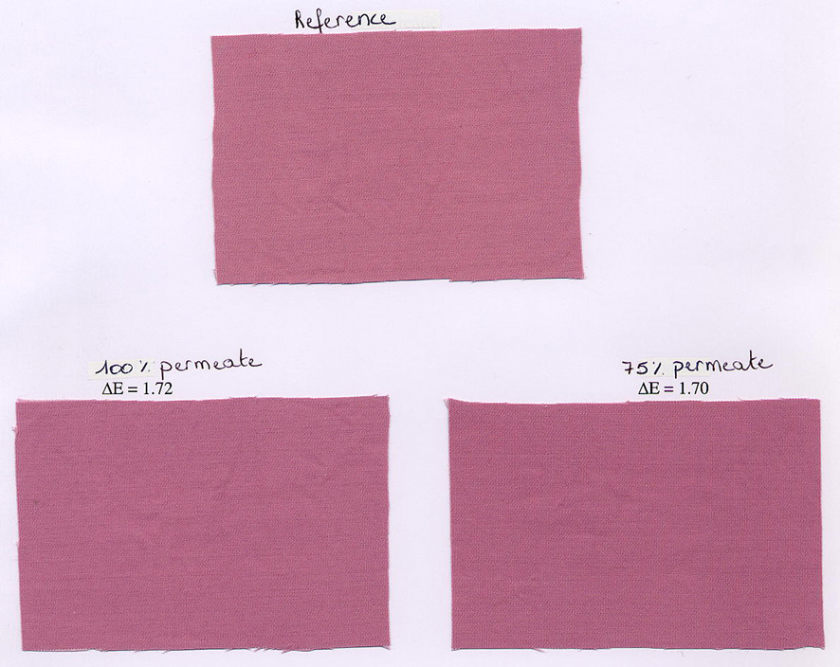
Figure 14: Colour differences of cotton fabric dyed with reference water and permeate of UF/NF (both 100% permeate and mixture of 75% permeate/25% fresh water)

The fastness properties were not negatively influenced. The pH of the permeate is easy to adapt, the salt content however is not easy to change.
On the other hand, textile processes in which little or no salt (NaCl) is dosed, the quality of the permeate is comparable to fresh process water and the quality of the treated (pre-treatment/dyeing) textile material is as good as the reference. As an example the dyed polyester fabric is shown in Figure 15. No significant colour differences can be noticed.

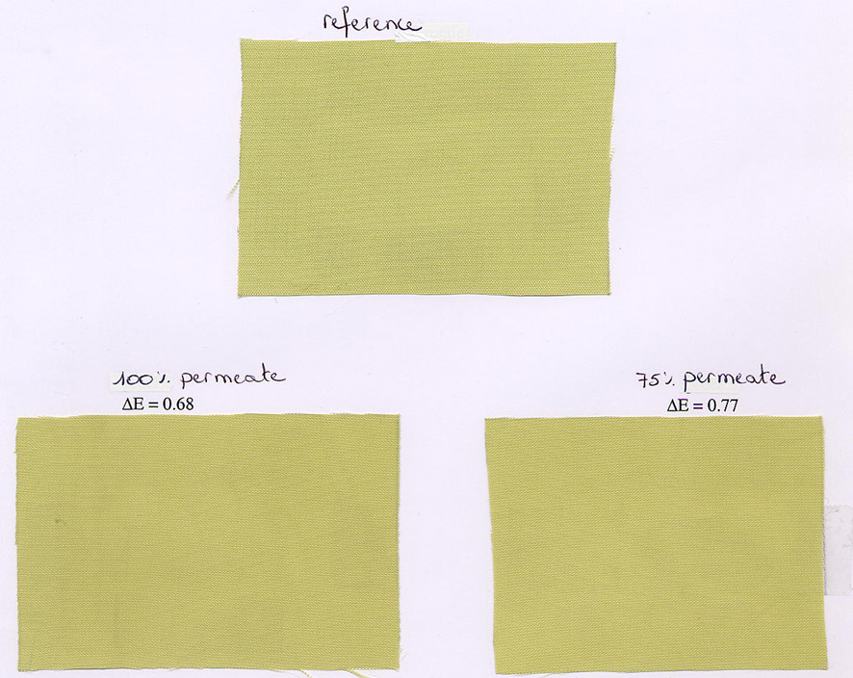
Figure 15: Colour differences of polyester fabric dyed with reference water and permeate of UF/NF (both 100% permeate and mixture of 75% permeate/25% fresh water)

As a conclusion we can state that the permeate of UF/NF or NF only, can be re-used for pre-treatment and/or dyeing of some of the most used textile raw materials, i.e. polyester, polyamide, silk, viscose. The presence of salt (NaCl) however hampers the re-usability for the dyeing of cotton.

Two important remarks are:
- only 1 re-use cycle has been evaluated,
- all the tests have been performed on lab scale and have not been validated on pilot or industrial scale.

Water pinch technology

Methodology
This part describes the different steps of the methodology that was used starting from the company-specific PIDACS till the design of an alternative water scheme in the dedicated software WaterTracker®.

a. From PIDACS towards data sheets
Starting from the PIDACS, the elaborated amount of data needed to be compiled into a surveyable format. All the useful information with regard to water minimization was extracted and summarized into Excel data sheets. The way the information was presented is illustrated in the Figure 16.

Figure 16: Example of data sheet
The following information is found in these tables:
- Process number and name as used in the PIDACS.
- Fabric on which this process is done.
- Machine on which this process is done.
- Number and name of the sub-sequence as used in the PIDACS.
- Water consumption & discharge for the different types of water.
- Contamination of the discharge.

These tables were used for preliminary, summarizing calculations: Waste waters from similar processes were grouped and their mixed flow rate and contamination was calculated. By grouping these similar flows, the amount of information to be entered into the visualisation software is reduced significantly.

b. Selection of reusable process effluents & Calculations
The selection of the streams was based on the experimental results from the membrane filtration trials and the reuse tests.

The main criteria to select streams for reuse are:
- No pretreatment or dye baths taken into consideration. These streams are often too concentrated for treatment by membrane filtration.
- The upper limit for the COD value is set at 1000 mg /l in order to reach, after filtration, sufficient low values for reuse of permeate. However, for some specific cases another limit was used. This is discussed further in the detailed descriptions of the different cases.
- The conductivity is preferable lower than 1000 µS /cm. This is important in case of reactive and sometimes acid and direct dyeing, where salt content plays a crucial role on the dyeing recipe. For other dyeing processes it can be expected that conductivity will anyway be below this value.

As a result, the different process effluents are grouped into non reusable - high contaminated discharges and reusable - low contaminated flows.
Pretreatment, dyeing and finishing departments were evaluated separately as they are often situated at different locations.

The Figure 17 illustrates how calculations were done in the data sheets. Contamination of the grouped process effluents is determined. As explained in paragraph a. these calculations were done in order to group similar process-effluents to reduce the amount of information to be entered into the visualisation software.

Figure 17: Example of calculation sheets
c. Information used from test results
The identification of reuse/recycle options of process effluents implies a knowledge of the maximum tolerated relaxation of the inlet water quality. Specific data for textile processes was gathered from literature data and from partners know-how. The Table 20 gives a non-exhaustive, qualitative list of possible relaxation -of the inlet water qualities- and reuse for different steps in a textile finishing company. Some quantitative ranges are given as well.
Table 20:Possible relaxations of process water quality
Process | Effluent | Relaxation
Desizing | Possible product recovery.  Permeate recyclable. | Low quality water accepted.
Prewashing | Possible regeneration. | Low quality water accepted
Bleaching | Possible reuse of rinsing waters.  Regeneration could be required. | High quality required  (COD<60mg/l and S.S.<5mg/l)
Mercerising | Recovery of NaOH
Dyeing | Possible reuse of rinsing waters.  Regeneration could be required. | High quality required  (COD<60mg/l and S.S.<5mg/l)
Printing | Possible reuse of rinsing waters.  Regeneration could be required. | High quality required  (COD<60mg/l and S.S.<5mg/l)

Due to the vast variation in textile processes and related effluents it is very hard to generalize the required inlet concentrations of the different steps. The values of the table below are used as reference general requirements for process water in the Belgian textile industry and have also been agreed with Italian industrial representatives.
Since the required quality is subjected to multiple parameters like the product colour (light or dark), the type of rinsing (first or final), the kind of dyestuff that is being used. Extensive testing is still required for every specific case.

Table 21: Reference values for water reuse
Parameter | Value
PH | 6.5 – 9
Hardness (°F) | < 5
Conductivity (µS/cm) | < 1000
COD (mg/l) | < 60
Fe (µg/l) | < 100
Mn (µg/l) | < 100
Colour | No visible colour or suspended solids

Secondly, results from the membrane filtration trials and the anaerobic lab test were used as a basis for the removal efficiency values of the introduced technologies in the software package WaterTracker®.
Only 17 different process effluents from the screened companies were tested. As a result, assumptions had to be made based on interpolations of these values for all other optimisations.

Finally, the economic evaluation of the effluent treatment was used as an additional guideline for the optimisation. It was illustrated that the higher the flow rate through the membrane filtration unit, the lower the cost per m³ treated water. However, above 50 000 m³ /year the cost decrease becomes minor. This is clearly illustrated in the Figure 18

Figure 18: Typical trend of membrane treatment costs in function of the effluent flow rate

d. Visualisation and optimisation
Based on the data sheets and calculations, the water network was visualized in the dedicated software WaterTracker® from Linnhoff March. Flow rates and concentrations of contaminations are entered. The software now calculates the overall water consumption and contamination of the final discharges.

Finally, all schemes were optimised by implementation of membrane filtration technology and anaerobic end-of-pipe treatment plant. Results from trials, reuse tests and economical evaluations were taken into account as described in previous paragraph.

Figure 19: Water schemes layout
The water saving potential, compared to the initial situation, was calculated by the software. Furthermore, the impact on the water quality parameters of the feed stream towards the processes (due to mixture with membrane permeate) was determined, as well as the increased contamination of the final effluent, as a result of the obtained water saving.

Scientific achievements
The methodology for Water Pinch application in the textile sector, described above in details, represents a major scientific achievement in line with the project objectives.

Its application showed that within a pretreatment department water savings from 30 to 70% can be obtained. Whereas in dyeing sections the savings, by implementing regeneration technologies, would be within a range of 15 to 40%. For the overall companies this would mean a reduction in water consumption between 15 and 30%. The contamination of the final effluent, as a result, will increase proportionally.

The costs for implementation of membrane filtration units is still relatively high (around 0.7 €/m³) compared to the actual low costs of industrial or ground water (around 0.1 €/m³). Only in case of expensive treatment of industrial or ground water, implementation of a regeneration technology will be feasible. On the other hand in the near future it can be expected that costs of the actual used industrial and ground water will increase. Secondly, the permits on pumping ground water will become more stringent. And finally, prices for membrane filtration will drop, due to the increasing market for this technology.

Main deliverables
D 8 - D 9 – D 14 Data source on relaxation possibilities of process inlet water quality. Optimal water re-use procedures applicable in the synthetic/silk/cotton industry. Integrated methodology for water pinch and waste water design.

Life Cycle Assessment

Methodology
LCA is one of the most known and internationally accepted methodologies to compare the potential environmental impacts of processes and systems and to evaluate their relative sustainability in the entire life cycle. In this project LCA methodology has been applied to selected textile products manufactured within Belgian and Italian textile finishing companies (Table 22) with the aim of identifying the environmental critical points, developing a database of Life Cycle Inventory (LCI) of textile processes and products to be used with the web based LCA software and supporting the choice of water saving scenarios.
Table 22 Products analysed by LCA methodology
Company | Product | Report
B02 | Cotton fabric | TM-108-007 Rev. 0
B05 | Cotton-PES fabric | TM-108-008 Rev. 0
I02 | Viscose fabric | TM-108-003 Rev. 1
I04 | Viscose fabric | TM-108-005 Rev. 0
I06 | Flax-PES fabric | TM-108-002 Rev. 1
I09 | Silk yarn | TM-108-004 Rev. 1
I15 | Silk fabric | TM-108-006 Rev. 0

The boundaries of the studied system are represented in Figure 20 and included the textile wet processing and the subsequent wastewater treatment in a Waste Water Treatment Plant, the energy and chemicals production, and the transport of wastewater sludge and auxiliary materials.

Figure 20: System boundaries of the LCA case studies.

Because LCA methodology requires detailed data (energy consumption, chemicals, water,..) on all the processes of the selected product chain, an LCA questionnaire, which have been developed taking into account the peculiar characteristics of the textile production processes, has been integrated into the PIDACS sheets.
A set of methods and assumptions for interpreting the PIDACS data has been defined. Criteria to assess process specific methane consumption starting from the annual energy balance of the firm, to evaluate the electricity consumption per kilogram of treated fabric and to model the final wastewater treatment plant have been included. These assumptions have been applied consistently to all Italian PIDACS because of the good homogeneity in data quality among the selected companies and are reported in detail in the LCA reports specified in Table 22. They form a sort of guideline for a better interpretation and use of the PIDACS data for LCA studies.

Scientific achievements (LCA application)
The selected products life cycle was analysed in detail. Each product has its own environmental profile and its own characteristics. Nevertheless some general conclusion can be drawn:
- The contribution analysis performed on the LCA results confirmed the importance of steam, electricity and chemicals production on the overall impact of the product life cycle. A typical example of such contributions is shown in Table 23. The potential environmental impacts of transport (WWTP sludge and chemicals) and management of WWTP is very small for all categories but eutrophication, for which WWTP impact includes the impact of the release of treated wastewater in the environment. Anyway, to avoid misunderstandings, it must be cleared that, because of a lack of specific toxicity and chemical characterization analyses on textile product effluents, aquatic, human and terrestrial toxicity categories do not include the potential impact of the introduction of the textile effluents in the environment.

Table 23: Example of contribution analysis for processing viscose fabric in I02 company
Inventory and Impact categories | Units | Chemicals production | Steam production | Electricity production | Transport | WWTP
Total Primary Energy | MJ | 10% | 57% | 33% | 0% | 0%
CML-Air Acidification | g equivalent H+ | 10% | 8% | 77% | 1% | 0%
CML-Depletion of non  renewable resources | fraction  of reserve | 10% | 68% | 22% | 0% | 0%
CML-Eutrophication | g eq. PO4 | 4% | 3% | 7% | 1% | 82%
IPCC-Greenhouse effect (direct, 100 years) | g equivalent CO2 | 10% | 50% | 39% | 0% | 0%
CML-Aquatic Eco-toxicity | 1e³ m³ | 9% | 34% | 55% | 0% | 0%
CML-Human Toxicity | g | 9% | 7% | 83% | 1% | 0%
CML-Terrestrial Eco-toxicity | t | 14% | 76% | 10% | 0% | 0%
WMO-Photochemical oxidant  formation (high) | g equivalent ethylene | 6% | 24% | 53% | 1% | 0%

- Water consumption
The water needed to treat 100 kg of products ranges between 5 and 42 cubic meters: it depends on the type of process, the used equipment, the selected fibre. The most part of water is used for rinsing and washing dyed or printed fabric, or for pre-treatments. The water used outside the company for energy or chemicals production is only a small part of the total: this confirms the opportunity to focus the water saving measures on the textile wet finishing phase.
- Energy consumption
Primary energy is the energy embodied in natural resources (e.g. coal, crude oil, natural gas, uranium) that has not undergone any anthropogenic conversion or transformation. It is an indicator of the efficiency of the use of energy natural resources in the overall system. In our systems primary energy consumption ranges between 2200 and 24000 MJ per 100 kg of treated fabric: it is connected to the quantity of fossil fuels burned mainly for steam production and in second place for electricity production. As table 1 shows, steam production is therefore a “hot spot” for several “energy related” impact categories.
Electric energy production is an important pollutant source mainly for acidification and ecotoxicity categories, because of heavy use of fossil fuels for the production of electric energy in Italy.
- Chemicals production
The impact of chemicals production is a small but not negligible fraction of the textile products life cycle impact for all the environmental impact categories, because of the big quantity of base chemicals used mainly in pre-treatment processes. Chemicals with specific environmental risk phrases R50, R51, R52, R54, R55, R56 and R57 have not been used in any Italian analysed product chain.

To fulfil the project objectives, LCA methodology has been used to evaluate the water saving scenarios selected on the basis of wastewater treatability and water reusability tests and chosen according to Water Pinch findings. The aim of this analysis is to verify if the adoption of water saving techniques can transfer pollution from water to other environmental media.
In the “innovative scenario” ultrafiltration and nanofiltration technologies were applied to selected wastewater flows (mainly rinsing water), with water saving of 10-35% of the total of the product. The histograms below (Figures 21 and 22) show the variation in water consumption and the effect on the overall environmental impact categories for Flax-Polyester fabric processing in I06 company. The water saving of 17% can be obtained with almost no additional load in the other main impact categories: the calculated impacts rise less than 1%. The determinant of these impacts is the electric energy consumption for the membrane treatment plant; anyway the absolute value of the increment is very low (22 MJ per 100 kg of product). Similar results can be observed for different products in the other companies.

Figure 21: Water consumption in the reference and innovative scenarios
Figure 22: Environmental impact categories in the reference and innovative scenarios

In the “Effluent zero scenario” ultrafiltration + reverse osmosis was used to treat effluents of viscose fabric processing in I02 company. The potential water saving was estimated in 80% (Figure 23). The electricity use in reverse osmosis plant, not compensated by the energy savings to extract from wells and to pre-treat less water, caused a worsening of the energy indicators and of the “energy related” impact categories (Figures 24 and 25). In this case the water saving should be weighted against the increment of the load in the other impact categories, taking in account the local environmental conditions and criticalities. The possibility to compensate for the increase of the electricity use adopting a more efficient energy policy in the company should be investigated too.
Figure 23: Water consumption in the reference and “effluent zero” scenarios

Figure 24: Energy indicators in the reference and “effluent zero” scenarios

Figure 25: Environmental impact categories in the reference and “effluent zero” scenarios

Another major result of this project is a LCA database containing quantitative data on processes/products used in textile wet processing companies.
The database can be used by LCA practitioners to complement the existing LCA commercial databases with specific information on textile wet processing and by non LCA experts in conjunction with the user friendly software.

Scientific achievements (LCA software tool)
The software facility (hereafter “the tool”) is based upon the Life Cycle Assessment (LCA) methodology (as referred to by the ISO14040 series of standards) and is designed for use by textile companies process engineers and decision-makers. The idea was to provide technical and non-technical people alike in the European textile industry with a tool enabling environmental impact assessments of process and waste water closed-loop recycling options, with a view to reducing water consumption as well as reducing the environmental burden associated with water treatment.
A “Users guide” and “Software Architecture” are provided together with the tool, in order to describe its content.

Tool Architecture
The tool is a Web based application: the user only needs a web browser to access the tool, all the software is located on a server so that many users can access it and use it at the same time, using the same database.
The calculations made on the server are performed by the TEAM software, Ecobilan's LCA software. The TEAM software has to be installed and licensed on the server before the tool, according to the corresponding installation procedure.
The code of the tool is written in 'php', an up-to-date web oriented language. The 'MySQL' database and 'Apache' web server have been chosen because they are provided with 'php' in 'Easyphp', a simple, powerful and open source package available for web based applications.
On the server, the software directly uses the environmental impacts database provided with TEAM, thanks to an ocx called ImpactDll.ocx. This interface allows the tool to obtain the list of available impacts and the list of their contributors. The impacts database is an Access database.
The TEAM calculation engine is launched by a daemon called 'calc.exe'. This daemon checks permanently in the MySQL database if a calculation is ready to be launched, and then provides TEAM with the relevant information. As the TEAM engine cannot be launched twice at the same time, this system allows multiple users to ask for as many simulations as they need, and the calculations will be performed in the chronological order. The TEAM engine produces inventories text files that will be imported by the tool in order to display the calculation results.
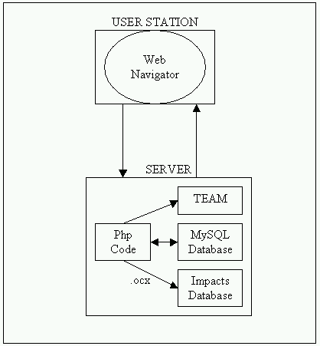
The Tool Architecture can be summarised as in Figure 26.
Figure 26: Tool architecture
Practical Achievement and Users Guide
The tool has been developed, and is now installed on a web server at ENEA, at the following address: http://192.107.65.184.

The practical achievement of the LCA tool is detailed as in Figure 27.

Figure 27: Structure of the software tool
This achievement is the practical application of the tool architecture to the project. The Users Guide details how to use the tool, from different access levels. It is distributed to the members of the project in order they start to practically work with the tool.

The tool offers four user profiles:
- The administrator user profile that enables user management
- The process user profile that enables the creation/modification of processes containing site specific data
- The project user profile that enables the creation/modification of projects and scenarios specific to users
- The user profile that enables the creation/modification of the projects on which the project manager gives access
Furthermore, once the users have ordered access, they are given a password and login to access the site, which enables them to access a personalised work environment, where they can store their specific data. Each project team handles the data it has implemented in the database thanks to the four user’s profiles.

The LCA Database
The overview of the content of the database is given in Figure 28.
Figure 28: Database content.
Each line in the database covers one textile process for which users of the tool will provide data using the Web interface. Each process is a subsystem in TEAM™. It contains process data plus the upstream (materials and chemicals production, energy supply…) and downstream (water treatment) datasheets covering the environmental impacts associated with the process. Parameters allow handling the processes from the Web tool. The Bleaching subprocess is described in Figure 29.

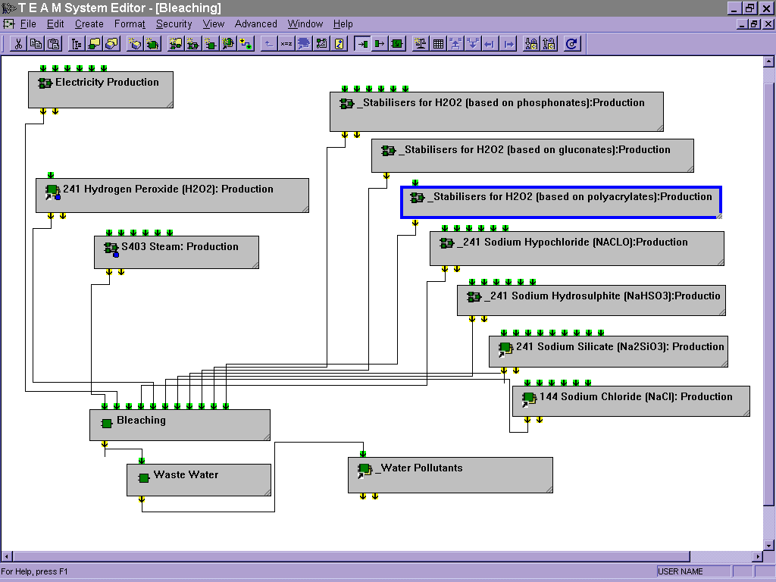
Figure 29: Bleaching subprocess description.

All subprocesses have been described as this one, which allows flexibility and easy access by LCA practitioners.

Main deliverables
D 20: Technical report on LCA application in textile finishing industry
D 21: Database Life Cycle Inventory
D 23 Software tool.

Environmental impact assessment

Methodology
A multi-component analysis method for polar organic environmental water pollutants was developed, based on sequential solid-phase extraction (SSPE) followed by single-stage liquid chromatography-mass spectrometry (LC-MS). Afterwards emphasis was placed on the analysis of the organic micropollutants with a new triple-quadrupole tandem LC-MS-MS instrument. Tandem LC-MS-MS is advantageous in terms of selectivity, sensitivity, reliability and rapidity in analysis.

Complementary to chemical characterization, ecotoxicological methods have been selected which allow to evaluate the environmental impact of textile effluents on receiving waters. A battery of ecological relevant tests, as they cover biological responses of 4 organisms (bacteria, green algae, invertebrate, fish) has been applied to industrial effluents, effluents from waste water treatments plants and chronic tests to receiving waters.
A guideline was developed to allow classification of effluents (Table 24). This classification is based on the response of the most sensitive organism expressed as toxic units (colour code) and on the cumulative effect score which does take into account the response of each of 4 organisms. This approach allows to order samples in either of 4 classes: no acute toxicity (< 1 toxic unit, blue), low acute toxicity (1-10 toxic units, yellow), acute toxicity (10-100 toxic units, red) to high acute toxicity (> 100 toxic units, black) (Table 24).

In addition, biological screening methods were applied for the measurement of estrogenic activity caused by contaminants present in textile effluents and released into the environment. These biological screening methods do allow to predict a potential impact of chemicals on reproductive ability of natural fish populations in rivers. Two validated in vitro estrogen-receptor-based assays, the MVLN-assay (human breast cancer cell line) and the YES-assay (yeast cells) were applied to extracts of environmental samples to detect the estrogenicity in effluents of textile industry (indirect discharges), effluents from municipal and industrial waste water treatment plants and in receiving waters.

Table 24: Criteria for classification of waste waters based on acute toxicity for 4 organisms
Result acute toxicity test |  | Classification in 4 categories |  | Cumulative effect score
EC₅₀/LC₅₀  (% dilution effluent) | Toxic units  (100 * 1/ EC₅₀ or LC₅₀) | based on response of most sensitive organism |  | based on the sum for toxic class of each organism
> 100% | < 1 | Not acute toxic | blue | 0
10 - 100% | 1 – 10 | Low acute toxicity | yellow | 1
1 - 10 % | 10 – 100 | Acute toxicity | red | 3
< 1% | > 100 | High acute toxicity | black | 5

Physical-chemical characterizations were performed with a multi-parameter in-situ water probe. The following parameters were measured in the effluent and receiving waters: pH, conductivity, turbidity, dissolved oxygen, temperature, colour (436 nm) and the standard absorption coefficient SAC (254 nm). Moreover, DOC and TOC were measured in the year 2002.

Scientific achievements
Textile industry effluents, effluents from municipal and industrial WWTPs treating the textile industry discharges, and the corresponding receiving rivers were investigated in Belgium and Italy with the developed analysis methods.
Generally, for the assessment of the environmental impact, the treated effluents of the textile industries or the WWTPs treating the appropriate effluents were analysed, and not the untreated or internal waste water fluxes.
The following Table 25 shows all sampling campaigns performed during the project.

Table 25: Water monitoring sampling campaigns
No. | Date | Location | Chem. | Ecotox.
1 | July 19, 2001 | At a textile WWTP in Fino Mornasco, N-Italy. | X
2 | April 2001- June 2002 | Belgium, textile effluents, WWTPs and receiving waters |  | X  (estrog. act.)
3 | October 23, 2001 | At different rivers (Seveso, Olona, Lura, Guisa, Pudiga) north-west and south of Milan, N-Italy | X
4 | June-October 2002 | Belgium, effluents of 5 textile companies |  | X  (acute ecotox)
5 | February 12, 2002 | Along the River Seveso which runs in the direction north to south from the area of Como to Milan, N-Italy | X
6 | June 12, 2002 | At three textile WWTPs in the area south of Como, Fino Mornasco, N-Italy | X | X  (acute tox. + estrog. act.)
7 | July 16, 2002 | At the Lake Maggiore, Ispra, N-Italy | X
8 | October 2002 | At three textile WWTPs in the area south of Como, Fino Mornasco, N-Italy |  | X  (chronic tox.+ estrog. act.)
9 | December 16, 2002 | In the area east of Milan at the River Lambro | X
10 | June 17-18, 2003 | Belgium: Oudenaarde, Ronse, Waregem;  River Schelde, creeks Molenbeek and Gaverbeek | X | X  ((estrog. act.)
11 | November 19, 2003 | Italy: Fino Mornasco, Bulgarograsso, Milan;  Rivers Seveso, Lura and Lambro | X | X  (estrog. act.)

Chemical pollutant analysis by SSPE-LC-MS
In June 2002 a big sampling campaign was jointly conducted at three textile industry WWTPs in the area south of Como. In summary, the following pollutant types were identified in the water samples: phenols (nitrophenols, bisphenol A, nonylphenol (NP)), alkylphenolethoxylate (APEO) surfactants and their metabolites with endocrine disrupting potential (NPE₁C, NPE₁O, NPE₂O, OPE₂O, etc.), different aromatic sulfonates, LAS surfactants, dyes (colorants), pesticides, and pharmaceuticals.
Special attention was attached to the detection of endocrine disrupting compounds (EDCs): short-chain APEOs, NP, OP, BPA, and carboxylated APEO metabolites (alkylphenolethoxy-carboxylates, APECs). NP and NPE₁C were found in all water samples spanning a concentration range of 0.46 μg/L to 12.5 μg/L for NP, and 0.58 μg/L to 14.8 μg/L for NPE₁C. Especially high NP concentrations were found in the Rivers Livescia (5.3 μg/L) and Lura (12.5 μg/L). NP was found in the effluents of all WWTPs (0.54 – 0.88 μg/L). Besides NPE₁C, also NPE₂C, and NPE₃C were detected in all water samples, also the effluents of the WWTPs. In Livescia, higher NP and NPEC levels were found in the receiving river than in the WWTP effluent. In Bulgarograsso and Seveso however, the concentrations were higher in the effluents. Dicarboxylated NPEO metabolites were found in all investigated rivers, but not in the effluents of the plants.
Linear alkylbenzene sulfonates (LAS) are commonly used domestic surfactants; C₁₀₋₁₃-LAS were found in all water samples. LAS are usually well removed in WWTPs by adsorption to the sludge as well as biodegradation. Only small quantities were found for these compounds in the effluents of the plants (0.8 – 2.3 μg/L). However, surprisingly high concentrations were detected in the Rivers Seveso, Lura, and Livescia (22.8 – 171.8 μg/L), and even higher concentrations in the rivers of the sampling campaign 9 at the River Lambro (16 December 2002).

Acute and chronic toxicity in Belgian and Italian waters
Effluents of textile companies and WWTPs were first evaluated by acute toxicity tests. Only if no acute toxicity could be detected the evaluation for chronic toxicity in receiving waters was performed. The effluents of 3 WWTP in Italy sampled in June 2002 did not show acute toxicity (Figure 30). Subsequently, a monitoring campaign to assess chronic toxicity was set up in October 2002 for WWTP effluents and receiving waters. Results did show no effects for early life stages of fish, minor toxicity for water flea for only one WWTP, while eutrophication of receiving waters through effluent discharge of all WWTP was demonstrated based on results of algae growth tests and reproduction of water flea. The textile companies in Flanders were also evaluated for acute toxicity in 2002. Except for one company waste waters were not (or not efficiently) treated, but were discharged to municipal WWTPs. The latter might explain acute toxicity of more than 10 toxic units in effluents end-of-pipe in each of 4 companies (Figure 30). Belgian municipal WWTPs which do receive also indirect effluents from textile gave low acute toxicity in influents, which only for Waregem WWTP was significantly reduced in the effluent (Figure 30). It was further demonstrated that each of 4 test organisms are important for screening of acute toxicity, as the most sensitive response was alternately seen for algae, bacteria, waterflea or fish.
Figure 30: Example of classification of different types of water samples in Italy and Belgium, based on measurements for acute toxicity, according to the guidelines outlined in the previous table

Chemical pollutant analysis by SPE-LC-MS-MS
In the Belgian and Italian effluents the following pollutant types were identified: phenols (nitrophenols, bisphenol A, NP, OP, nonylphenolethoxylate (NPEO) surfactants and their metabolites with endocrine disrupting potential (NPECs, NPE₁O, NPE₂O, OPE₂O, etc.), different aromatic sulfonates, LAS surfactants, dyes (colorants), pesticides, and pharmaceuticals.
Sewage effluents from textile industry are a major source for (alkylphenolic) endocrine disrupting compounds (EDCs) in the aquatic environment; the elimination of these substances in WWTPs is therefore of special interest.
Among the EDCs investigated, NP, NPE₁C, and NPE₂O had the highest concentrations in the water samples. In the Italian and Belgian waters, the highest NP levels were found in the receiving waters, the highest NPEC concentrations however in the WWTP effluents, and in Belgium the highest NPE₂O levels in the textile plant effluent of CB5. High NPEO concentrations for all oligomers (n = 3-17) were found in the textile plant effluent CB5 (sum 11.2 μg/L), the Creek Molenbeek (3.6 μg/L), and the River Lambro in Milan (22.6 μg/L).

Physical-chemical characterizations
In the Italian textile WWTP effluents Livescia, Bulgarograsso and Seveso physical-chemical pollution was observed for the parameters conductivity, turbidity, temperature, TOC, DOC, SAC, and colour in comparison to the receiving rivers.
In Belgium, in two textile WWTP effluents significant higher values were found for the physical-chemical parameters conductivity, temperature, colour (436 nm) and SAC (254 nm) (Table 26). Especially the high temperature of CB5 plant effluent was worrying. These results show the environmental impact of the textile industries in terms of physical-chemical pollution.
Table 26: Physical-chemical parameters for the Belgian textile companies CB4 and CB5 and the corresponding receiving waters; Medium values from three measurements; Sampling campaign 17-18 June 2003.
Location | Conductivity [S/m] | Temp. [ºC] | Colour 436 nm [m⁻¹] | SAC 245 nm [m⁻¹]
B4 WWTP effluent | 1.4 | 28.0 | 8.6 | 64.2
WWTP Oudenarde | 0.2 | 19.8 | 0.6 | 6.5
River Schelde before WWTP | 0.1 | 24.7 | 0.7 | 3.1
River Schelde after WWTP | 0.1 | 24.8 | 0.9 | 3.6
B5 plant effluent | 0.9 | 46.9 | 10.4 | 106.7
Creek Molenbeek before effluent | 0.2 | 18.1 | 1.7 | 10.8
Creek Molenbeek after effluent | 0.2 | 23.6 | 6.0 | 38.5

Measurements of estrogenic activity by hER gene reporter yeast assay (YES)
Monitoring campaigns in Italy and Belgium did demonstrate levels below detection limit in effluents of Italian WWTP up to relatively high levels in receiving waters in Italy (7,0 ng/l E2 equivalent) and Belgium (11,8 ng/l E2 equivalent). In a few cases, estrogenic levels in rivers and creeks did exceed 5 ng/L E2 equivalent, which is suggested to cause hazardous effects to normal reproduction of fish populations.
Estrogenic activity in surface waters, being higher than those measured in industrial textile effluents and effluents of WWTPs might be due to the occurrence of NP. This metabolite of the nonylphenol ethoxylates, surfactant chemicals which are known to be used in textile industry, is formed in the effluents and receiving waters.

Integration of biological and chemical analysis with regard to estrogenic activity
As a result of the simultaneous monitoring and analysis of Belgian and Italian waters with either chemical or biological methods, results could be compared. For each of the measured chemical pollutants, which are suspect for endocrine disrupting activity, the relation with the measured estrogenic activity in the bioassay was investigated. A highly significant correlation between the estrogenic signal and concentrations of bisphenol A in Belgian waters was demonstrated, which was less pronounced for Italian surface waters and WWTPs. Other significant correlations with estrogenic activity were found for NPE₁C in Belgian industrial effluents and surface waters, for NPEOs in Italian WWTPs and surface waters, and for NPECs in Italian surface waters. When all the available data on estrogenic activity in Belgian and Italian waters were pooled, only for NP a significant correlation was found.
Based on knowledge of relative potency of the EDCs BPA, NP, OP, NPE₁C, NPE₂C, NPE₁O and NPE₂O and the measured concentrations, an estimation could be made of the contribution of these chemicals to the estrogenic activity in the sample. The correlation between the estrogenic activity and the chemicals detected was better for Italian than for Belgian waters. For surface waters, in most cases less than 10% of estrogenic activity could be predicted by chemical analysis. This does indicate that both chemical and biological approaches are complementary, and that other chemical compounds do occur in surface waters which have a significant contribution to the measured estrogenic activity. It is suggested, in comparison to literature data, that major compounds are likely to be the natural and synthetic estrogenic hormones (17β-oestradiol, oestrone, oestriol and 17α-ethinyloestradiol), which are the result of diffuse pollution from household and agricultural run-off.

Conclusions
Method selection and validation for both acute and chronic ecotoxicity, and for detection of estrogenic compounds was finished and applied for Flemish and Italian textile industry. A successful characterization of toxicity in samples of effluents of WWTP and receiving waters in Italy has been performed through 2 monitoring campaigns in 2002. It was demonstrated that discharges of Italian WWTPs had minor environmental impact with regard to the release of toxic substances. On the other hand some evidence was given for eutrophication. Effluents of Belgian textile industry did show acute toxicity. Measurements in effluents of WWTPs in Belgium showed a significant reduction of acute toxicity.
The developed SPE-LC-MS and MS-MS multi-component analysis procedures were successfully applied to the chemical analysis of the treated effluents of textile industries (WWTPs) and the corresponding receiving waters. Urban and industrial pollution was observed in rivers and streams in Belgium and in Italy.
The endocrine disrupting compounds (EDCs) NPEOs, NP, and NPECs are released into the environment from textile industry WWTPs in considerable amounts. NP and NPECs are formed from the NPEO surfactants in WWTPs and the receiving waters. They are difficult to remove in WWTPs. These results show that NPEOs are still used in industry. The predicted no-effect concentration (PNEC) for NP of 0.33 μg/L for water species was frequently exceeded in the waters (up to 2.5 μg/L), suggesting potential adverse effects to the aquatic environment. The concentrations for the non-regulated NPEOs and NPECs were even higher. This shows the need to improve water quality by cessation of toxic emissions into the environment. The use of NPEO surfactants should be phased out. In addition to these alkylphenolic EDCs, in Belgium especially high and worrying pesticide concentrations were found in the water samples. Through comparison of biological and chemical measurements a significant correlation was demonstrated between NP levels and estrogenic activity for pooled data from Italian and Belgian monitoring campaigns. In addition, for selected groups of samples, correlations were found between estrogenic activity and other EDCs such as bisphenol A, and some of the NPEOs and NPECs.

Main deliverables
D17: Compendium of analytical methods for organic micropollutants.
D18: Protocol for ecotoxicological characterisation.
D19: Report on the effluents characterisation.

Regulatory policy
The analysis of regulation policies concerning industrial water services was structured commencing with a general overview of the main economic theories on regulations to place the emphasis on environmental regulation through the tariff instrument.
The outline on theoretical fundamentals for the definition of tariff models was combined with the benchmarking analysis of some European systems: specifically, industrial tariff models adopted in Italy, U.K., Germany and France have been compared in details.
The joint analysis of both the economic principles of tariff’s regulation for water sector and the international systems surveyed resulted in the definition of a standardised water tariff model designed to fit the needs of the industrial sector in a specific basin. In particular, the competences of the public Authority in terms of regulation at basin level to the basin regulation have been established, together with its planning and control functions.
Furthermore, an empirical application was simulated of the tariff models for industrial water treatments in Italy, U.K. and Germany, including also the model intended to verify any tariff variations on the basis of five textile companies with a single treatment plant. The analysis is based on two scenarios: in the first assumption the water consumption and pollutants concentration are measured for a manufacturing structure which doesn’t refer to the reuse of the resource; in the second assumption, the same values are extimated for the same companies in an innovative manufacturing context based on the adoption of technologies allowing the internal reuse of the resource. The analysis has been conducted through a software specifically designed.
To ensure the adoption of innovative technologies, on one side, and not to burden certain industrial sectors, on the other, it is appropriate to consider tariff systems that take account of the quantities of water discharged, as well as the specific characteristics of treatment plants. In fact, the adoption of algorithms built on the basis of the technical characteristics of the plant and the type of users in the area served can provide impetus to a synergy between industry and regulators to define and implement a common course of action centered around a rational and informed use of water resources. The recommended tariff model should be assessed against this background. This model combines some distinctive features of the so-called “Mogden formula”, adopted in Italy and the United Kingdom, and the possibility to grant a direct tariff reduction as a result of the firm’s effort in the environmental field.
This tariff articulation, according to the practical results obtained by the simulation, permits to recognize in the tariff the reductions of the volumes due to the introduction of technologies for the reuse of the resource.
From this standpoint, the introduction of a tariff system capable of meeting environmental needs and the company’s goals in terms of economic development and productivity growth, should be evaluated in light of several factors. First of all, the introduction in textile companies of technological systems capable of reusing water in the productive process should go hand in hand with a policy enacted by regulators on the types of water treatment plant to be built in the relevant basin. It is crucial not only to encourage environmental awareness in companies but also to undertake planning in water management activities. To this end, in addition to an algorithm capable of generating environmental awareness for companies, the tariff model recommended calls also for a regulatory system based on the hydrographic basins and user categories present in the area. This regulation model implements an integrated safeguard system for the territory, capable of combining an environmental-friendly attitude by firms with the presence of treatment plants in keeping with the characteristics of the geographic areas in which they operate and the quality of the polluting agents produced by local users. While tariffs can spur the industrial sector directly, the introduction of an environmental fund and planning the actions to be taken on the individual hydrographic basins safeguard and protect the system. An “integrated” strategy is the only way to introduce a regulatory water management system that matches a rational use of this resource with the needs of the geographic area of reference. For this reason both the delimitation of the relevant basin and the strategic role assigned to the regulators of the planning and control interventions are important, because the average costs of the water treatment are subdivided among all the companies located on the territory.
This model of regulation can increase the realization of investments for both new technologies related to the water reuse and sewage treatment plants functional to the concentration of pollutants present in the discharges, given that the tariff structure proportionally subdivides the costs among the companies working in the basin. This system allows to overcome the peculiarities of the SMEs, implementing an environmental policy economically sustainable for the manufacturing sector.

Main deliverables
D 27: Report on the practical prototype for a water management regulatory policy.

Conclusions including socio-economic relevance, strategic aspects and policy implications
All the specific results described in the previous section, beside being valuable and applicable independently, were synergically combined to create an Integrated multicriteria methodology. The methodology can be described as a four steps optimisation process:
- Complete data collection to be carried out in the companies
- Analysis of all (or at least the most important) process effluents to identify and characterise all its possible destinies (direct reuse, reuse after on site treatment, direct discharge to WWTP, discharge to WWTP after on site pretreatment…)
- Elaboration of all the data gained in step 2 in a Water Pinch assessment, resulting in the definition of optimised water reuse scenarios
- Comparison of the scenarios by LCA methodology to support the decision making leading to the implementation.
Following the implementation of the new water reuse scenarios in the companies, continuous monitoring of the impacts on receiving water bodies is required to compare the results with the previously existing situation.

A company can, on the one hand, make preliminary evaluations using the integrated methodology and the data produced by the project and, on the other hand, design detailed water reuse schemes producing ad hoc data as input to the methodology.
The integrated methodology may give an effective contribution to the application of the IPPC directive and, enabling a sustainable use of the water in critical industrial sites, it represents a good methodology for similar approaches in other industrial sectors. It contributes to the social objectives of the Community allowing for a lower consumption of high quality water through the maximisation of water re-use and recycling, by protecting recipient water bodies and the environment as a whole through assessment of the impacts, avoiding pollution transfer to air and soil.

Besides the effects of the integrated methodology other project achievements have a potential socio-economic relevance and or policy implications.

The survey on Good Environmental Practice, having been used in the BREF, has a direct implication into environmental legislation. BREFs are result of information exchange under Article 16(2) of the IPPC Directive and should be taking into account when issuing new environmental permits for the Textile Industry (as well as other industries in Annex I of the IPPC Directive) above a certain threshold.

The methodology elaborated for the data collection and its tool (PIDACS) showed to be an effective way of gathering information that are normally disperse in companies. It allows for integrated evaluations like the allocation of the final environmental impacts to the sources of the pollution (i.e. performed processes). It is an useful tool to conduct environmental screening in industrial sectors.

As for the effluents characterisation and design, the development of infrared measurement procedure may yield a novel technique for on-line COD measurement of textile wastewaters, and has the potential to be developed for market applications.
The combination of respirometric and infrared techniques may yield a method to measure the treatability of not only textile wastewaters but also other industrial effluents.

The feasibility analysis of effluents treatment supported by the effluent reuse assessment, illustrates the costs required to implement the reuse strategies. These results, compared to the costs of primary water, especially when implemented in a water pinch evaluation carried out at company level, allow for a preliminary cost benefit evaluation.

The Water pinch showed a good applicability in the textile industry and it has an economic relevance due to good results it can obtain in conducting optimisation of the water use in a cost effective way.

The socio-economic relevance of Life Cycle Assessments is clearly understood if one considers the economic cost of remedying pollution in the various recipient bodies as well as the negative impacts on living conditions due to a poor environmental record.
The software tool is aimed at helping textile industries keep the environmental impacts associated with their business under control and possibly reducing them. Regulators should benefit from the facilities and the approach provided by the tool in the way of progressing environmental friendly policies for the textile sector.

As for Environmental impact assessment, the methodology for ecotoxicological characterization developed might be implemented by government as an effect-based instrument to assess waste water quality and quality of receiving waters. This strategy is also supported by the OSPAR working group on ‘Whole effluent assessment’, considering criteria such as toxicity, persistency and bioaccumulation. Moreover, in vitro screening assays have shown to be a suitable instrument for detection of hazardous compounds with endocrine disrupting activity. The added value of biological measurements is clearly demonstrated through the comparison of the estrogenic activity and the chemical analysis of suspected EDCs.
The developed multi-component chemical analysis method for polar organic water pollutants using SSPE followed by LC-MS, the new method based on tandem LC-MS-MS detection, as well as the method for the analysis of alkylphenolic EDCs are suitable instruments for water monitoring sampling programmes of polar organic environmental priority and emerging water pollutants. They contribute to the harmonization of analytical methods in order to provide internationally agreed methods, and to the implementation of the Water Framework and IPPC Directives. Moreover, the monitoring results from the field campaigns give useful environmental information to the public as well as policy-makers, considering the lack of reliable monitoring data in Europe.
Measurement data did show that the NP quality standard was regularly exceeded and that estrogenic activity in Italian and Belgian surface waters was of that order of magnitude that normal fish reproduction could be hampered. It is confirmed that the European strategy with regard to EDC should be of high priority and that chemicals with known hormone disrupting activity should better be phased out, and be part of monitoring programmes as a follow-up.

Finally, to support the introduction of effective BAT in the industry the optimisation proposed for the regulatory policy play as an incentive, pushing towards the implementation of Good Environmental Practices without depleting the competitiveness of textile finishing industries.

Dissemination and exploitation of the results
A workshop on the state of the art derived from the collected data, involving end-users and stakeholders was organised and held in Belgium the December 9th, 2002, in order to diffuse the results of the survey on Good Environmental Practices.
The meeting was organised with Belgian Textile Industry. More than 50 people attended the meeting. The knowledge by the Belgium companies of the good environmental practices as well as the Best Available Techniques determined under the exchange of information between Member States and Industry concerned was of great interest for the audience. Environmental permit writers, also present during the workshop, showed also great interest. Creating such occasion for an exchange of information between permit writers and textile industry was a relevant result because the IPPC directive asks them to discuss to renew the operation production permit for the installations.

A workshop on waste design (WD) was held in Paris on October the 1st 2003. The aim was the discussion on how the WD, that is already partly integrated in the overall project methodology, can fully be applied in the textile industry and in similar industrial sectors. In order to collect ideas and integrate different points of view, the cooperation of invited expert was required. It was an occasion to present in detail the project TOWEF0 to the invited experts and this way contribute to the dissemination, but it was mainly a way to identify new possible applications of this approach. During the workshop clearly emerged the necessity of a big research effort to really assess all the issues connected to the waste design in the industry and an hypothesis of research project was laid out.

The final Workshop on integrated Wastewater Management in textile finishing industry was organised and held in Bologna on February the 27th . Textile associations and their members (through the Italian Textile Association) were specifically invited as well as the European Commission and several researchers in similar fields. The programme focused on the results and conclusions of the project. The final outputs of the project were summarised, showing how they can be integrated in the multicriteria methodology and applied in the companies. Various questions were collected from the participants during the workshop requiring more explanation on some specific results and their applicability in the textile companies.

The dissemination of the project results was also increased by the participation of the project partners in various national and international conferences and workshops, the main events are reported below:
- Euro Summer School on Water and Resource Recovery in Industry; Wageningen, 26-31/8/2001
- Think tank meeting: Finishing and environment, Gent, 5/6/02
- Symposium on water issues in the Flemish textile industry, Gent, 9/12/02
- ECO-EFFICIENCY BIENNIAL workshop on Technologies and solutions for eco-efficient management of water in the textile sector; Torino 4-7/6/2003
- Workshop: Water Pinch Technology, Gent, 3/9/03
- PATANTEX European Workshop on Environmental Challenges for the Textile, Leather and Pulp and Paper Industry; Copenhagen 18-19/9/2003
- European Conference H2Obiettivo 2000 on liberalisation and privatisation of water services; Trieste 24-26/9/2003
- Workshop: Water treatment technologies: measuring and testing, Gent, 9/10/03
- Ecomondo International Trade Fair - Workshop on Environment and Textile- Rimini 22-25/10/2003
- Workshop: Membrane Technology, Gent, 30/10/03
- Flemish workshop “Hormone disruption: concern for environment and human health in Flanders”, 21st November 2003, organised by Vito

Part of the results of the project are disseminating with the BREF itself. BREF is available in the internet site http://eippcb.jrc.es maintained by the IPTS/JRC/EC. Just as a matter of example, the BREF on Textile has been read more than 2000 times since July 2003. Such documents are not only read by European companies or administration. These document are read by all over the world and we know that specifically the textile BREF have had a great diffusion in Australia and India.

Main literature produced
Authors | Title | Journal | Reference
D. Mattioli. F. Malpei. G. Bortone and A. Rozzi 2002 | Water minimisation and reuse in the textile industry | Water Recycling and resource recovery in industry. IWA Publishing | pp. 544-584
Iemke Bisschops, Henri Spanjers 2003 | Literature Review on Textile wastewater Characterisation | Environmental Technology | vol. 24, pp. 1399-1411 (2003)
André B. dos Santos, Iemke A.E. Bisschops, Francisco J. Cervantes, Jules B. van Lier 2003 | Effect of different redox mediators during thermophilic azo dye reduction by anaerobic granular sludge and comparative study between mesophilic (30 ºC) and thermophilic (55 ºC) treatments for decolourisation of textile wastewaters | Chemosphere | Accepted
André B. dos Santos, Iemke A.E. Bisschops, Francisco J. Cervantes, Jules B. van Lier 2003 | The transformation and toxicity of anthraquinone dyes during thermophilic (55 ºC) and mesophilic (30 ºC) anaerobic treatments | Journal of Biotechnology | Submitted
R. Loos, G. Hanke, S. J. Eisenreich 2003 | Multi-component analysis of polar water pollutants using sequential solid-phase extraction followed by LC-ESI-MS | J. Environ. Monit. | 5 (2003) 384-394
R. Loos, G. Hanke, S. J. Eisenreich | Comparison of Sequential Solid Phase Extraction (SSPE) with single SPE and Liquid Chromatography Single-Stage Mass Spectro-metry (LC-MS) with Triple Quadrupole Tandem LC-MS-MS for Multi-Residue Analysis of Organic Water Pollutants |  | To be published shortly
R. Loos, G. Hanke, S. J. Eisenreich | Analysis of Nonylphenol Ethoxylate Surfactants (NPEOs), Octyl- and Nonylphenols, Carboxylated NPEC Metabolites and Bisphenol A in Water by Solid-Phase Extraction and Liquid Chromato-graphy Single-Stage and Triple-Quadrupole Tandem Mass Spectrometry |  | To be published shortly
H. Witters, R. Loos, P. Berckmans, C. Vangen-echten, G. Hanke, S.J. Eisenreich | Correlations between organic micropollutants and estrogenic activity in textile and waste water treatment plant effluents and receiving waters in Belgium and Italy |  | In preparation
Mattioli D., De Florio L. and Giordano A. 2003 | Textile industry effluent treatability for reuse. | Proceedings of Ecomondo International Trade Fair - Rimini, | pp. 403-409
Valeria Dulio 2002 | Reference Document on Best Available Techniques for the Textile Industry |  | Downloadable at http://EIPPCB.jrc.es

EC50/LC50: concentration of compound or dilution of effluent at which for 50 % of the organisms a toxic effect (E) or lethal effect (L) does occur.

